# Subcontractor Estimating Guide

### Table of Contents

* Basic Process for Completing the Subs Tab
* Define the Line Items and Materials for Each Subcontract
* Identify Allowances for Subcontractor Jobs
* Interpret the Bids
* Level the Bids

### Basic Process for Completing the Subs Tab

There are multiple steps that go into completing the Subcontractor Phase of a construction project. Essentially, you will scope the work that you are subbing out, use the NCE to estimate the rough cost of materials and labor for completing the subcontract work, then comparing and leveling bids from various subcontractors to arrange the best possible prices for the various work to be completed.

Back to the Top

### Define the Line Items and Materials for Each Subcontract

The line items and materials will usually be predetermined in the Estimating Workbook. If they are not, you should refer to the Building Plans, Scope of Work documents, or contact the Project Manager to identify the line items and materials to be used for subcontracting jobs.

One important part of this step is completing takeoffs in Bluebeam for items that are measured in LF and SF. For example, when estimating ceramic tile, you will need the SF of flooring that will have tile installed to really estimate the scope of the job.

Back to the Top

### Identify Allowances for Subcontractor Jobs and Line Items

Refer to the Specification Sheets in the Building Plans to find any allowances specified for various cost items that fall under subcontractor jobs.

Back to the Top

### Interpret the Bids

Look at all the bids for a specific Subcontractor job.

* This is not always as clear as it would appear. Sometimes a subcontractor can do multiple line items outside the scope of one specific subcontractor job. For example, a mechanical company could do items from both the electrical subcontractor job and the HVAC subcontractor job.

Identify any scope gaps found in the bids. Are there items outlined in the Specification Sheets and the Estimating Workbook that are not included in a bid?

Do the bids include Alternates, which can be added to bid for a specified price?

Identify any quality gaps between bids. Are some bids providing pricing on items that do not meet the specifications for the project?

Back to the Top

### Level the Bids

After reviewing all the bids, your job is now to choose the best and least expensive subcontractor to do the specified work. Bid leveling is a great way to make the best decisions on which bids to accept.

#### Step 01: Add the Bids for a Job into the Bid Leveling Spreadsheet

Bid leveling consists of checking the line items of each subcontractor bid and comparing them to ensure each bid includes the same work. If you find that a bid is missing certain required line items for the job, you should contact them to ask for the cost of adding those items.

**Example:** The following image shows three bids for an HVAC job input into a bid leveling spreadsheet.

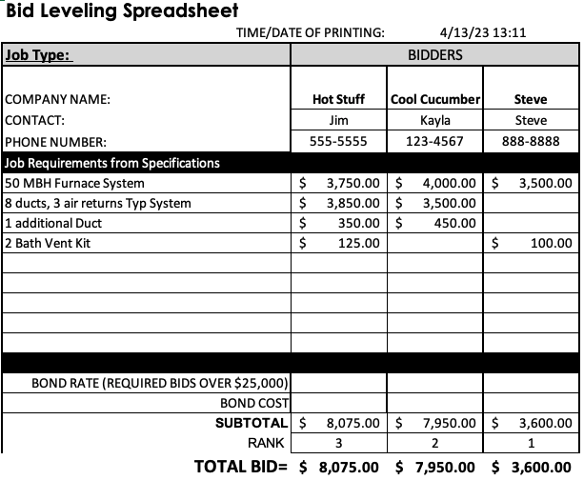Notice that Steve is the lowest bidder, but his bid does not include pricing for any duct work. Cool Cucumber is the next lowest bidder, but does not include pricing for the bath vent kits. Hot Stuff is the highest bidder, but includes pricing for all required line items for the job.

#### Step 02: Request or Estimate any Missing Line Items

Contact the subcontractor rep for any bids that are missing line items. If they are willing to do that work, they will give you pricing for it. Add the additional pricing to their bid. If they do not provide additional pricing, you can also add the pricing for that line item from another bid to help you rank the bids more accurately.

**Example:** You contacted Kayla at Cool Cucumber to request pricing for two bath vent kits. She gives you the pricing of $150 ($75 each). You also contacted Steve to ask about pricing for the duct work, but he says that he does not do that kind of work. Instead of adding the pricing from one of the two other bids for Steve's missing line items, you leave it blank. Because Steve is not willing to do the work required you do not choose his bid.

#### 

Now that levelling has been completed, Hot Stuff is the actual lowest bid that will complete all of the required work.

#### Step 03: Decide on a Bid to Accept

Accept the bid that offers the best overall pricing. There may be circumstances that require you to choose a slightly higher bid, such as preferred subcontractors, personal experience, etc. In general, though, you want to maximize your profit by choosing the most economical bid for subcontractor work.

Back to the Top

Read this online at <https://books.byui.edu/construction_estimat/bid_leveling_guide>