# Wage Rate Calculation Walkthrough

Rey, S.

## What is Wage Rate?

In order to more accurately estimate the labor costs of a construction project, the estimator should calculate the total cost to the construction company per hour to employ each worker in a crew. This number is the wage rate, and is more than just the hourly wage workers are paid per hour.

### Wage Rate Formula



### Table of Contents

* Scope of Work
* Video Walkthroughs
* Calculate Total Taxable Wages
* Calculate Employer Non-Taxable Contribution
* Calculate Employer Tax Contribution
* Calculate Unemployment, Workers’ Compensation, and Liability Insurance Premiums
* Calculate Total Net Annual Payroll
* Calculate Total Billable Hours Per Year
* Calculate Average Hourly Wage Rate

#### Important!

Some of the numbers provided for various figues (eg. Employer Contribution Rates) may not match the figures for your assignment. This is done intentionally to demonstrate how the calculations are made, but to not do the work for you.

### Wage Rate Calculation Scope of Work

Your completed spreadsheet should meet all of the following critera.

#### Taxable Wages Section

Complete the calculations for each of the following figures (displayed in orange):

* Overtime Wage Rate
* Number Regular Hour Per Year
* Number Overtime Hours Per Year
* Yearly Regular Wage ($)
* Overtime Wages Per Year ($)
* Total Taxable Wages Per Year ($)

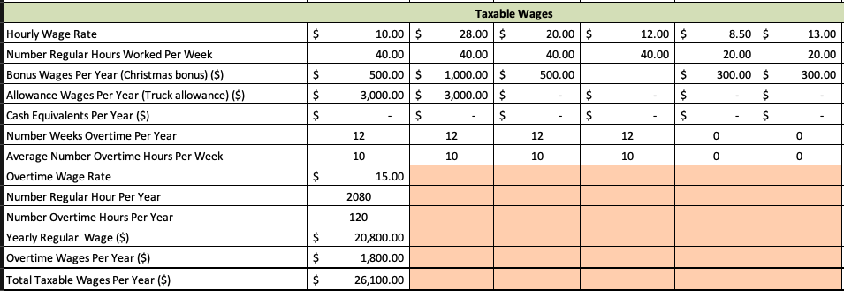

#### Non-taxable Wages Section

Complete the calculations for each of the following figures (displayed in orange):

* Yearly Employer Health Insurance Premium
* Yearly Employee Health Insurance Premium
* Employer 401(k) Yearly Matching Contribution ($)
* Employee 401(k) Yearly Contribution ($)
* Total Employer Non-Taxable Contribution Per Year
* Total Employee Non-Taxable Withholding Per Year

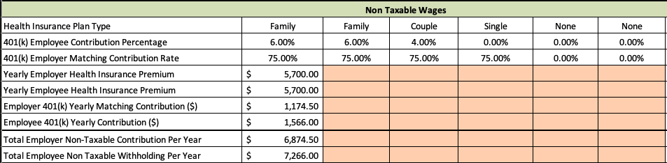

#### Employer Tax & Insurance Contributions Section

Complete the calculations for each of the following figures (displayed in orange):

* Total Employer FICA Contribution Per Year
* Total Unemployment Premium Per Year (FUTA)
* Total Unemployment Premium Per Year (SUTA)
* Total Worker's Compensation Premiums Per Year ($)
* Total Liability Premiums Per Year ($)
* Total Net Annual Payroll Amount ($)

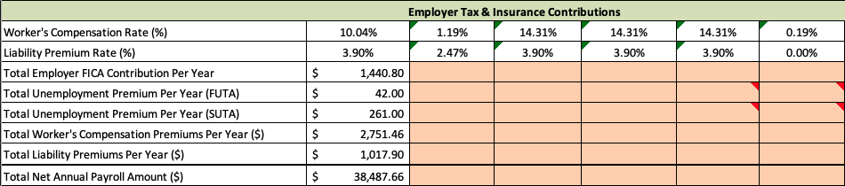

#### Billable Hours Section

Complete the calculations for each of the following figures (displayed in orange):

* Total Number Hours Paid Per Year
* Total Non-Billable Hours Per Year
* Total Billable Hours Per Year
* Average Hourly Wage Rate

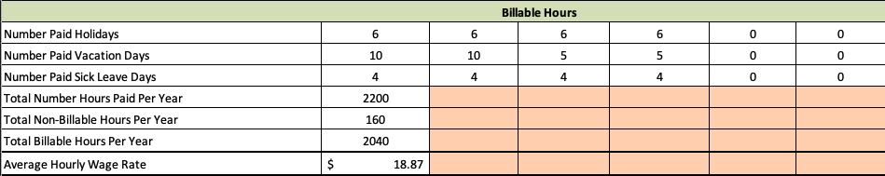

### Wage Rate Calculation Video Walkthroughs

Wage Calculator Assignment Walkthrough (Part 1), 23:28 mins

Wage Calculator Assignment Walkthrough (Part 2), 43:01 mins

### Taxable Wages Calculation

Taxable Wages are all payments and taxable benefits provided to employees. It is calculated using the following steps:

**Step 01:** Calculate the **total regular wages** per year by multiplying the hourly wage by the total number of regular hours.

|  |
| --- |
| **Example:** John Doe is a full-time employee with an hourly rate of $10.     * Hourly Rate = $10 * Regular Hours = 2,080 hrs   **Total Regular Wages =** $20,800.00 ($10 x 2,080 hrs) |

**Step 02:** Calculate the overtime rate (1.5 x regular hourly wage).

|  |
| --- |
| **Example:** John Doe is a full-time employee with an hourly rate of $10.   * Hourly Rate = $10 * Overtime Rate = 1.5 x Hourly Rate   **Overtime Rate =** $15 per hour |

**Step 03:** Calculate the total number of overtime hours per year.

|  |
| --- |
| **Example:** John Doe is a full-time employee with an hourly rate of $10.   * Overtime Weeks = 12 wks/yr * Overtime Average Hours = 10 hrs/wk   **Overtime Hours per Year =** 120 hrs |

**Step 04:** Multiply the overtime rate by the total number of overtime hours, then add it to the total regular wages.

|  |
| --- |
| **Example:** John Doe is a full-time employee with an hourly rate of $10.   * Overtime Rate = $15 * Overtime Hours = 120 hrs * Total Overtime Wages = $1,800 ($15 x 120 hrs)   **Total Wages =** $22,600.00 ($20,800 + $1,800) |

**Step 05:** Add the value of any bonuses, allowances, and cash equivalents.

|  |
| --- |
| **Example:** John Doe is a full-time employee with an hourly rate of $10.   * Bonus: Christmas = $500.00 yr * Allowance: Truck = $3,000.00 yr * Total Bonus & Allowance = $3,500.00 ($500.00 + $3,00.00)   **Total Taxable Wages =** $26,100.00 ($22,600.00 + $3,500.00) |

Note that the following items will be pre-populated in any estimation worksheet that includes labor: Worker Hourly Wage, Regular Weekly Hours, Bonuses, Allowances, Overtime Weeks, and Overtime Average Hours.

### Non-Taxable Wages Calculation

Non-taxable Wages are benefits paid to employees that are not subject to payroll tax. They include Health Insurance Premiums from both the employee and employer and Retirement Plan Contributions from both the employee and the employer.

For the purposes of construction estimating, both employee and employer contributions to these benefits is taken into account when calculating Total Non-taxable Wages. To calculate this figure, follow these steps:

**Step 01:** Calculate the Yearly Employer Health Insurance Premium.

|  |
| --- |
| **Example:** John Doe is a full-time employee who has the family health insurance plan.       * Family Plan Premium (monthly) = $800.00 * Family Plan Premium (annual) = $9,600.00 (12 x $800.00) * Employer Contribution Percentage = 70%   + This figure comes from the InsuranceDB tab, and does not match the number used in your own assignment.   **Yearly Employer Health Insurance Premium =** $6,720.00 ($9,600.00 x .7) |

**Step 02:** Calculate the Yearly Employee Health Insurance Premium.

|  |
| --- |
| **Example:** John Doe is a full-time employee who has the family health insurance plan.   * Family Plan Premium (monthly) = $800.00 * Family Plan Premium (annual) = $9,600.00 (12 x $800.00) * Employee Contribution Percentage = 30%   **Yearly Employer Health Insurance Premium = $2,880.00 ($9,600.00 x .3)** |

**Step 03:** Calculate the Employer 401(k) Yearly Matching Contribution.

|  |
| --- |
| **Example:** John Doe’s employer matches 80% of his 401(k) contributions.   * Employee 401(k) Yearly Contribution = $783.00 * Employer 401(k) Matching Contribution Rate = 80%   **Employer 401(k) Yearly Matching Contribution = $626.40** |

**Step 04:** Calculate the Employee 401(k) Yearly Contribution.

|  |
| --- |
| **Example:** John Doe is a full-time employee with a yearly taxable wages total of $26,100.00. John Doe contributes 3% of his taxable wages to a 401(k) retirement account.   * John Doe Taxable Wages = $26,100.00 * John Doe 401(k) Contribution Percentage = 3%   **Employee 401(k) Yearly Contribution = $783.00 ($26,100 x .03)** |

**Step 05:** Calculate the Total Employer Non-taxable Contribution Per Year.

|  |
| --- |
| **Example:** John Doe is a full-time employee.   * Yearly Employer Health Insurance Premium = $6,720.00 * Employer 401(k) Yearly Matching Contribution = $626.40   **Total Employer Non-taxable Wages per Year = $7,346.40 ($6,720.00 + $626.40)** |

**Step 06:** Calculate the Total Employee Non-taxable Withholding Per Year.

|  |
| --- |
| **Example**: John Doe is a full-time employee.   * Yearly Employer Health Insurance Premium = $2,880.00 * Employee 401(k) Yearly Contribution = $783.00   **Total Employee Non-taxable Withholding per Year = $3,663.00 ($2,880.00 + $783.00)** |

Note that the following items will be pre-populated in any estimation worksheet that includes labor: Health Insurance Plan, 401(k) Employee Contribution Rate, and 401(k) Employer Matching Rate.

### Employer Tax Calculation

**Step 01:** Look up the current year FICA Earnings Limit on the Social Security Administration’s website ([ssa.gov](https://www.ssa.gov/)).

|  |
| --- |
| **Example:** John Doe is a full-time employee.       * John’s 2018 Total Taxable Wages = $26,100.00 * 2018 FICA Earnings Limit = $128,400.00   **John’s wages are below the limit, so all of his taxable wages will be subject to FICA taxes.** |

**Step 02:** Calculate the Wages Subject to FICA Contributions, which are equal to total taxable wages - yearly employee health insurance premium - yearly employee 401(k) contribution.

|  |
| --- |
| **Example:** John Doe is a full-time employee.   * Total Taxable Wages = $26,100.00 * Yearly Employee Health Insurance Premium = $2,880.00 * Yearly Employee 401(k) Contribution = $783.00   **Wages Subject to FICA Contributions = $22,437.00 ($26,100.00 - $2,880.00 - $783.00)** |

**Step 03:** Calculate Total FICA Contribution (15.3%).

|  |
| --- |
| **Example:** John Doe is a full-time employee.   * Wages Subject to FICA Contributions = $22,437.00   **Total FICA Contributions = $3,432.86 ($22,437.00 x .153)** |

**Step 04:** Calculate Employer FICA Contribution (50% of total contribution).

|  |
| --- |
| **Example:** John Doe is a full-time employee.   * Total FICA Contributions = $3,432.86   **Employer FICA Contributions = $1,716.43 ($3,432.86 x .5)** |

### Employer Insurance Contributions Calculation

By law, employers are required by law to carry Federal Unemployment Insurance (FUTA), State Unemployment Insurance (SUTA), and Workers’ Compensation Insurance. Employers should also carry Liability Insurance to shield them from claims for bodily injury, property damage, or loss that may arise as a result of failing to use reasonable care in conducting business.

The cost of these insurance premiums contribute to the cost of labor, and should be accounted for when completing a construction estimate. They are calculated as follows:

**Step 01:** Look up the current year FUTA Tax Rate on the Internal Revenue Service’s website ([irs.gov](https://www.irs.gov/)).

|  |
| --- |
| **Example:** John Doe is a full-time employee.     * John’s 2018 Total Taxable Wages = $26,100.00 * 2018 FUTA Tax Rate = 6.00% on the first $7,000.00 of wages   **John’s wages are over $7,000.00, so the FUTA Premium will be calculated for $7,000.00.** |

**Step 02:** Calculate the Total FUTA Premium.

|  |
| --- |
| **Example:** John Doe is a full-time employee.   * John’s 2018 Total Taxable Wages = $26,100.00 * 2018 FUTA Tax Rate = 6.00%   **Total FUTA Premium = $420.00 ($7,000 x .06)** |

**Step 03:** Look up the current year SUTA Tax Rate on the Idaho Department of Labor’s website ([labor.idaho.gov](https://www.labor.idaho.gov/)).

|  |
| --- |
| **Example:** John Doe is a full-time employee.   * John’s 2018 Total Taxable Wages = $26,100.00 * 2018 SUTA Tax Rate = 1.00% on the first $38,200.00 of wages   **John’s wages are below $38,200.00, so the SUTA Premium will be calculated based on his total taxable wages.** |

**Step 04:** Calculate the Total SUTA Premium.

|  |
| --- |
| **Example:** John Doe is a full-time employee.   * John’s 2018 Total Taxable Wages = $26,100.00 * 2018 SUTA Tax Rate = 1.00%   **Total SUTA Premium = $261.00 ($26,100 x .01)** |

**Step 05:** Identify the Workers’ Compensation Rate for each employee, and the Workers’ Compensation Premium Adjustment (Mod Factor). These will both be available in any estimating worksheet for labor.

|  |
| --- |
| **Example:** John Doe is a full-time employee.   * **John’s Workers’ Compensation Rate = 10.04%** * **Employer’s Mod Factor = 1.05%** |

**Step 06:** Calculate the Workers’ Compensation Premium before Mod Factor.

|  |
| --- |
| **Example:** John Doe is a full-time employee.   * John’s 2018 Total Taxable Wages = $26,100.00 * John’s Workers’ Compensation Rate = 10.04%   **Workers’ Compensation Premium (before Mod Factor) = $2,620.44 ($26,100 x .1004)** |

**Step 07:** Calculate the Workers’ Compensation Premium after Mod Factor.

|  |
| --- |
| **Example:** John Doe is a full-time employee.   * Workers’ Compensation Premium (before Mod Factor) = $2,620.44 * Mod Factor = 1.05%   **Workers’ Compensation Premium = $2,751.46 ($26,100 x 1.05)** |

**Step 08:** Identify the Liability Premium Rate for each employee. These will be available in any estimating worksheet for labor.

|  |
| --- |
| **Example:** John Doe is a full-time employee.   * **Liability Premium Rate = 3.9%** |

**Step 09:** Calculate the Liability Premium.

|  |
| --- |
| **Example:** John Doe is a full-time employee.   * John’s 2018 Total Taxable Wages = $26,100.00 * Liability Rate = 3.9%   **Liability Premium = $1,017.9 ($26,100 x .039)** |

Note that the following items will be pre-populated in any estimation worksheet that includes labor: Workers’ Compensation Rate (each employee), Workers’ Compensation Premium Adjustment, Federal and State Unemployment Tax Rates and Limits, and Liability Insurance Rate .

### Total Net Annual Payroll Calculation

Total Net Annual Payroll is the annual cost of an employee to the employer. It includes all wages, taxes, benefits, and insurance premiums paid by the employer. This is the number that will be used to eventually calculate the average hourly wage rate to use when estimating the labor cost of a construction project. It is calculated as follows:

**Step 01:** Calculate the Total Net Annual Payroll.

|  |
| --- |
| **Example:** John Doe is a full-time employee. The following totals from 2018 represent all employer-paid costs for John’s employment.  **Total Net Annual Payroll = $39,703.19 (sum of all employer costs for John’s employment)** |

### Billable Hours Calculation

Billable Hours is the number of hours that can be attributed to work on projects for each employee over a year. In construction estimating. It is different from the number of hours paid each year. Billable Hours is calculated using the following steps:

**Step 01:** Calculate the Total Hours Paid per year.

|  |
| --- |
| **Example:** John Doe is a full-time employee.     * Regular Hours per Year = 2,080 * Overtime Hours per Year = 120   **Total Hours Paid = 2,200 hrs (2,080 + 120)** |

**Step 02:** Calculate the Total Non-billable Hours per year.

|  |
| --- |
| **Example:** John Doe is a full-time employee.   * Paid holidays = 6 days/yr x 8 hrs/day = 48 hr/yr * Paid vacations = 10 days/yr x 8 hr/days = 80 hr/yr * Paid sick leave = 4 days/yr x 8 hr/day = 32 hrs/yr   **Total Non-billable Hours = 160 hrs (48 + 80 + 32)** |

**Step 03:** Calculate the Total Billable Hours per year.

|  |
| --- |
| **Example:** John Doe is a full-time employee.   * Total Hours Paid = 2,200 hrs * Total Non-billable Hours = 160 hrs   **Total Billable Hours = 2,040 hrs (2,200 - 160)** |

### Average Hourly Wage Rate Calculation

As stated at the beginning of the Quick Guide, Average Hourly Wage Rate uses the following formula:



**Step 01:** Calculate the Average Hourly Wage Rate.

|  |
| --- |
| **Example:** John Doe is a full-time employee.   * Taxable Wages = $26,100.00 * Non-taxable Wages = $7,346.40 * Employer Tax and Insurance Contributions = $6,256.79 * Total Billable Hours = 2,040 hrs   **Average Hourly Wage Rate = $19.46** |

This article contains original and curated content by BYU-Idaho. It is compiled and licensed under a [CC BY-SA 4.0 license](https://creativecommons.org/licenses/by-sa/4.0/).

Read this online at <https://books.byui.edu/construction_estimat/wage_rate_calculatioU>