# 1.3 Line Upon Line

Learning Objectives: • Understand and be able to identify each of the following: how falsification is used in science, the meaning/utility of falsified scientific theories, and how new scientific theories emerge from earlier theories. • Illustrate how scientific theory succession occurs using the transition from Earth- to Sun-centered theories of the Universe and the transition from Newton’s Theory of Gravitation to Einstein’s Theory of Relativity.



Dr. Brian Tonks and Dr. Dan Moore, Physics and Geology Departments, BYU-Idaho

No lie can live forever. —Thomas Carlisle

## Learning Objectives:

* Understand and be able to identify each of the following: how falsification is used in science, the meaning/utility of falsified scientific theories, and how new scientific theories emerge from earlier theories.
* Illustrate how scientific theory succession occurs using the transition from Earth-to-Sun-centered theories of the Universe and the transition from Newton’s Theory of Gravitation to Einstein’s Theory of Relativity.

Science as a path to truth emerged slowly from a foundation laid in ancient Greece. These early thinkers used pure rational thought—reasoned knowledge—to explore reality. They were deeply committed to the underpinning that humanity is capable of understanding nature, but they lacked key aspects of science. Greek philosophers like Plato believed that the senses (observations) could not be trusted, that rational thought was the only test of truth about nature —because the Greeks believed that their gods routinely used supernatural powers and deceived mortals.

Despite this limiting perspective, Plato’s student Aristotle made important progress in elevating the importance of objective observations—but his commitment to observations as a test for truth was inconsistent. Further progress was made as Christianity infused Western Civilization. These Christians believed that God created nature and that, as a being of truth, God could not lie or deceive. During the Renaissance, this trust grew into a deepened commitment to objective observations. In this way, scientific observations became an important tool in the search for truth.

Today, humanity recognizes the limitations of scientific underpinnings, but early Greek thinkers rigidly considered many underpinnings as unassailable. For example, Plato argued that celestial objects like the Sun, Moon, and planets could only move in perfect circles because they were perfect objects. Likewise, ancient Greeks rigidly accepted some explanatory models as true—so long as they were logically consistent. Despite the tremendous accomplishments of these early philosophers, they failed to consistently use observational tests and to appropriately consider the limits of underpinnings and explanations. These shortcomings blocked their search for truth and weakened their ability to generate practical applications of their explanatory models.

During the Renaissance, modern science emerged as humanity began to place observational testing in its proper place as the arbiter of truth about how nature works. As science developed, humanity was able to approach underpinnings and explanatory models less rigidly and recognize practical applications that improve the human experience—such as scientific  
medicine and modern transportation.

The development of humanity’s ideas about the Universe beautifully illustrates the emergence of modern science and powerfully exemplifies the self-correcting nature of scientific knowledge—which results from a commitment to observation as an arbiter of truth about the physical world. We begin with Aristotle’s notions about nature and then track that forward through the ideas of Copernicus and Newton to the implications of Einstein’s famous ‘relativity’.

## From Reasoned to Discovered Truths

Aristotle’s Universe divided nature into a corruptible earthly realm made of earth, water, air, and fire and an unchanging heavenly sphere composed of quintessence. This model contained explanatory power but rigidly embraced gross inaccuracies and produced many logical-but-false conclusions. For instance, it asserted that Earth is stationary at the center of the Universe because it is made of the heaviest element. During the Middle Ages, dogmatic adherence to Aristotelian explanations stifled human progress—including the rejection of Aristarchus’ more accurate Sun-centered model of the Universe.

Although the Aristotelian Universe seems silly to the modern mind, it provided rational explanations for aspects of nature that humanity had observed but could not explain naturally—things like rain falling from the sky. Despite these successes, Aristotelian explanations failed to accurately describe aspects of nature like the forward motion of thrown objects and the orbits of planets. Sadly, instead of accepting the inaccuracies and developing better models, the ancients and their successors clung tenaciously to their beloved underpinnings and created convoluted modifications that ‘preserved’ false explanations.

Following the fall of the Roman Empire in the 4th century AD, many Greek and Roman ideas were lost to Western Civilization. Then, from ~1000-1400 AD European scholars rediscovered these ideas in Arabic libraries, translated them into Latin, and began to reintegrate the attitudes, assumptions, and explanations of classical antiquity into Western Civilization. In areas such as governance and natural ‘science’, the ideas of Plato and Aristotle were particularly influential.

This integration, which included the fusion of the Christian plan of salvation and the Aristotelian Universe, exemplified the Western expectation of consistency—the notion that all aspects of the Western worldview should comprise a harmonious whole. At the time, many non-Western societies had no such expectation. The integration strategically located humanity on Earth’s surface, between the perfect and unchanging home of God in the heavens and the disorderly and hellish abode of Satan in Earth’s interior. In this model, righteous souls accumulated ‘quintessence’ during life, which carried them into the heavens when they died—and disobedient individuals accumulated ‘earth’ during life and sank to join the devil when they died.

In this way, the plan of salvation became inextricably connected to false ideas about nature—like the false notion that Earth lies at the center of the Universe. This unfortunate fusion of spiritual worldview with falsehoods about the physical world initiated the common Western notion of warring science and religion. For, as humanity began discovering truths about nature, dogmatic Middle-Age religionists sought to defend spiritual truths using erroneous ideas about the physical world. In so doing, they worked vigorously to repress developing scientific ideas, which were true.

Unfortunately, many modern religionists blindly persevere in this effort by seeking to defend important spiritual truths using false notions about nature. This effort is doomed, for nothing good comes of protecting truth with error. Sadly, scientific dogmatists have returned the favor over the centuries, by trying to use true notions about nature as clubs with which to bludgeon spiritual notions like God’s existence or life’s purpose. This effort is likewise doomed. As you can see, the so-called battle between science and religion is a struggle between scientific and religious dogmatists, not between discovered and revealed knowledge. Lamentably, many well-intentioned people are seduced by the siren songs of scientific and religious fundamentalists.

Now, let’s return to the development of scientific ideas. Despite its inaccuracy, the Aristotelian model of the Universe was not replaced until humanity developed a reliable path to discovered knowledge in the 1700s, nearly two millennia after Aristotle died. This path, known today as ‘science’, uses objective observations and empirical testing to identify false explanations of  
nature.

Some of the individuals that helped develop scientific explanations of the Universe are shown in **Figure 1.4**. Copernicus, true Renaissance man, was trained in law and medicine, proficient in music, active as an administrator of his Catholic parish, and the most influential astronomer of his generation. Copernicus, who considered Aristotle’s Earth-centered notions ‘offensive to common sense’, used mathematical arguments to develop a Sun-centered model of the Universe. Knowing that the dogmatic religionists of his day would punish him for opposing an Earth-centered Universe, Copernicus’ Sun-centered model was not published until just before his death. The improved accuracy of his method caused astronomers to adopt his mathematical method as a ‘useful but not real’ tool.

Before long, the growing importance of objective observation as tests for truth and the work of astronomers like Tycho Brahe, Johannes Kepler, and Galileo Galilee grew support for the Sun-center Copernican Universe. For example, Tycho’s 1572 observations of comets and a new star demonstrated that the heavens change, which falsified the Aristotelian assertion that the heavens were eternally unchanging. Later, Johannes Kepler used Tycho’s observations to demonstrate that planets follow oval (elliptical) paths, not circular paths—which falsified another cherished Greek underpinning. With several dogmas falsified, humanity began to wonder if Greek philosophy-infused Christian dogmas might be wrong about other things.

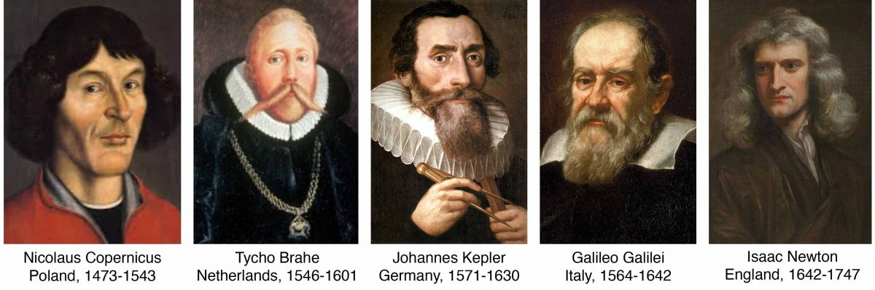

Figure 1.4. Important individuals in the discovery of progressively more accurate models of the Universe.

(Early scientific discoverers, Author illustration, created as a work for hire by Eden Platt using these trimmed public domain images: Nicolaus Copernicus, Toruń Town Hall portrait, unknown painter, https://bit.ly/3r8bBjY; Tycho Brahe, Eduard Ender, https://bit.ly/3up8E0F; Johannes Kepler, unknown painter, https://bit.ly/3uganFj; Galileo Galilei: Justus Sustermans, https://bit.ly/3JgvIml; Isaac Newton: Godfrey Kneller, https://bit.ly/3LIw0ny. Licensed as CC-BY-SA-3.0.).

Galileo, often considered the father of modern science, was among the first to make astronomical observations using a telescope. His observations of mountains on the Moon, changing sunspots, the phases of Venus, and four moons orbiting Jupiter strengthened the growing realization that the Aristotelian worldview was false. What’s more, Galileo’s observations of moving objects falsified the Aristotelian notion that heavier objects fall faster than light objects. Galileo’s keen intellect approached the study of motion by simplifying the complexity of moving objects. This approach introduced a new scientific underpinning called reductionism that strengthened humanity’s ability to learn about natural processes and laid the foundation for the work of Isaac Newton.

Galileo was an aggressive advocate of the Sun-centered Theory of the Universe. As a result, The Inquisition censured him, forced him to recant, and placed him under house arrest for the rest of his life. Although this episode has been interpreted in many ways, it certainly strengthened an increasingly chilly relationship between science and religion. The work of Galileo and his predecessors caused many to begin examining the underpinnings humanity used to interpret the natural world.

These and other inspired discoveries began, line upon line, to remove the shackles of dogmatism with which Western Civilization was bound and to identify the principles required to discover truths about the natural world. This reexamination of underpinnings culminated in the work of Sir Isaac Newton, who used key insights to synthesize the work of earlier thinkers. For example, Newton formulated laws of motion and gravitation and a Theory of Gravity. As the first to explain how Sun-centered planetary systems form, Newton completed the Copernican revolution. Moreover, he established modern science by enshrining observation as the arbiter of truth about the natural world.

In the centuries following Newton, his explanations were tested in as many ways as humanity could devise. The numerous confirmations of predicted observations produced extremely high confidence that Newton’s ideas were true. Then, in the early 1900s, Albert Einstein demonstrated that Newton’s Theory of Gravity was false, that gravitational forces do not exist. Astoundingly, Einstein demonstrated that what we think of as gravity does not result from invisible attractive forces, but from something altogether different.

## Theory Succession: From Newton to Einstein

Newton’s Theory of Gravity is tremendously successful at describing how objects move in many situations. In fact, for more than two centuries humanity used the very best instruments in the most clever ways to try to falsify the Theory of Gravity. We tested the theory over and over and over again, in every imaginable way. But humanity could not find a situation that wasn’t accurately described by Newton's Theory of Gravity. The theory worked to explain how planets move and objects fall—every single time. Astonishingly, Gravity Theory allowed humanity to predict and observe a never-before-seen planet, Neptune. Following so many confirmations, humanity's confidence in the validity of this Theory was incredibly high—for only very true explanations can so consistently describe things ‘as they are’.

At the time, humanity rightly considered that the Theory of Gravity was true. How true? True enough to correctly explain all the relevant aspects of nature that humanity had observed to that point. However—despite centuries of stupendous explanatory success—gravitational forces are not real, and Einstein’s work proved it. If it seems confusing that the Theory of Gravity can be both 'false' and 'true', don't be too alarmed—you're in good company. Much of humanity has yet to master the ideas required to resolve this apparent conundrum.

If you don’t take the opportunity to understand this, you will struggle to interact productively with the scientific ideas that permeate your life.

So, what is gravity? To visualize gravity, imagine you swing a ball-on-a-string overhead. When you do, the string keeps the ball from flying away. Make sense? Now, similar to the string, gravitational forces the planets like Earth to stars like the Sun. So, gravity—the central idea in Newton's Theory of Gravity—is an unseen force that pulls objects together. For example, dropped objects fall because Earth's gravitational force pulls on them. This is how humanity explained the motion of dropped, thrown, and orbiting objects from the late 1600s through the early 1900s—and it's the idea that most people still use to explain these things. But the idea is false.

Observations suggesting that gravitational forces don’t exist began appearing in the mid-1800s. Mercury provided one such example. Try as they might, humanity could not explain Mercury’s orbit using gravitational forces. Then, in the early 1900s, Albert Einstein identified important groups of observations that he proposed could not be explained by Newton's Theory of Gravity. Eventually, Einstein’s work proved that gravitational forces do not exist. In doing so, Einstein demonstrated the limits of the applicability of Newton's Theory. In addition, Einstein developed a new theory. This new theory was able to explain all the observations—those that gravity could explain and those it could not.

So, what happened to gravity? Humanity replaced this incredibly useful preparatory truth with a more-true explana􀀍on of how things move called the Theory of Relativity. In this way, limited preparatory knowledge, that for a time validly explained all human observations, was replaced by more-true preparatory knowledge. Remarkably, recognizing the limits of a preparatory truth like gravity doesn’t destroy its utility. Thus, despite being false, gravity will forever be a valid description of the physical world—but only in those areas of nature that it accurately describes. In this way, preparatory truths form useful approximations of absolute truths.

This changing character of scientific explanations frustrates some. Inexperienced truth seekers sometimes expect the whole truth 'right now!', and dogmatic fundamentalists believe they already 'pretty much have the whole truth'. These individuals sometimes hold perspectives like this, "Those darned scientists claim to be so certain about everything, but they're always changing their minds. I see right through their charade. They use their popularity, prestige, and so-called 'certainty' to foist falsehoods—the philosophies of men—on the unsuspecting, to diminish faith, and to carry out Satan's work. Well, I won't be fooled!!!" Perhaps you know someone who sees science in this light.

In contrast, experienced scholarly disciples are not surprised when scientific explanations change, such as when a scientific theory is falsified and succeeded by a more-true scientific theory. In fact, they expect this to happen because they recognize that all knowledge—discovered, revealed, and reasoned—accumulates 'line upon line, precept upon precept, ... until the perfect day'. In addition, scholarly disciples do not equate ‘philosophies of men’ with scientific theories. Instead, they recognize that ‘philosophies of men’ are reasoned ideas that lack the correspondence with reality that characterizes discovered truths. Importantly, if you want all the truth ‘right now!’, prefer to falsely classify discovered knowledge as ‘the philosophies of men’, or want to consider the truth you have as 'pretty much all you need', searching for truth may be the wrong endeavor for you.

Notably, remaining deeply committed to and defending already-discovered explanations while simultaneously searching for more-true replacements produces a dynamic tension that characterizes scholarly disciples. Living in this frame of mind tempts some to throw up their hands and exclaim, "This is all just way too hard and frustrating. I'll wait until God sets these faithless scientists straight." Attractive as it seems to some, this approach is deeply flawed. Those who choose to ignore the 'lines' God gives us now will likely find themselves unprepared to understand or acknowledge future revelations and inspired discoveries. Now, lest the bar to scholarly discipleship appears unattainably high, we remind that approach, desire, and progress are essential, but accomplishment and location on the path that leads to truth are not.

At this point, people are usually anxious to learn how objects actually fall and move. Although the full explanation requires years of training, the basic notions of relativity are within the reach of all. The core idea of the Theory of Relativity can be expressed in this simple sentence: Matter tells spacetime how to curve, and curved spacetime tells matter how to move. Read that sentence again, and then study **Figure 1.5**—which illustrates how matter (mass) alters spacetime. As you can see, an object placed on the dimpled grid would ‘fall towards’ or orbit the Sun or Earth.

So, what humanity thought were gravitational forces were in fact the product of curved spacetime. That is, warped spacetime causes dropped objects to ‘fall’ and orbit. It's true—at least far more true than gravity. Like Gravity Theory, the Theory of Relatively could one day be replaced by a more-true explanation, but for now, it’s the truest explanation humanity has—and everyone who cares about truth is really happy to have it.

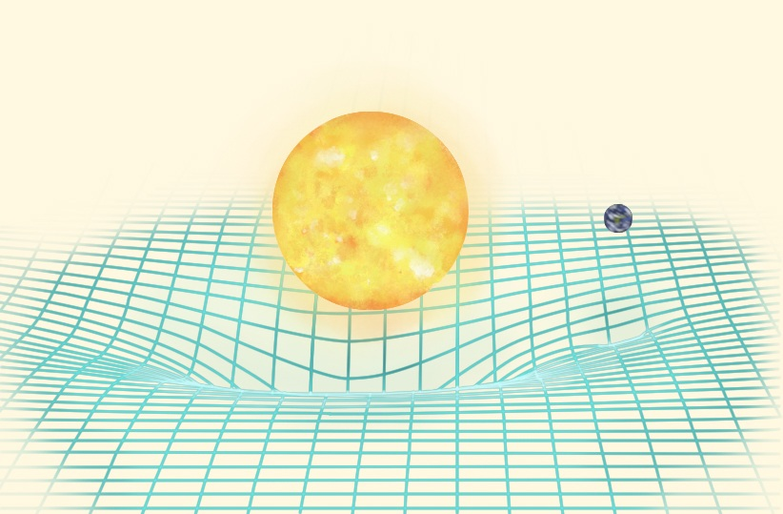

Figure 1.5. Image illustrating how the Sun and Earth ‘stretch’ or ‘curve’ a grid representing two dimensions of spacetime.

(Curved spacetime, Author illustration, created as a work for hire by Eden Platt after T. Pyle/Caltech/MIT/LIGO image, https://bit.ly/3LMOkMd. Licensed as CC-BY-SA-3.0.)

## For The Curious

The Beginnings of Western Science by David Lindberg (2nd Edition, 2008, University of Chicago Press).

Relativity: A Very Short Introduction by Russel Stannard (2008, Oxford University Press).

The Logic of Scientific Discovery by Karl Popper (2nd edition, 2002, Routledge Classics).

Read this online at <https://books.byui.edu/from_atoms_to_humans/13_line_upon_line>