# 2.8 A Star is Born

Learning Objectives: • Understand and be able to identify each of the following: normal stars, mini stars, nebulae, globules, proplyds, and nuclear fusion. • Analyze the birth of stars in terms of governing processes and system states separated by transitions; specifically, how gravity and fusion produce the normal star state from a globule in a nebula. • Describe how a change in one of the following proper􀀍es of a normal star will affect the other properties: mass/gravity, fusion rate, true brightness, and temperature (all of which are proportional to each other); and lifetime (which is inversely proportional to the other properties).

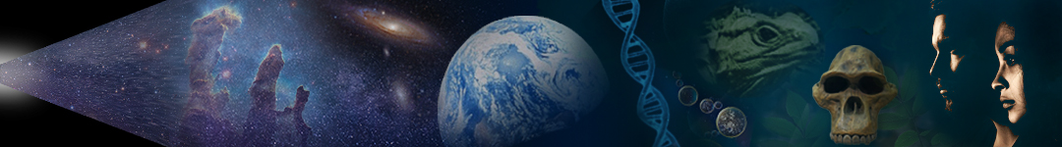

Dr. Brian Tonks and Dr. Dan Moore, Physics and Geology Departments, BYU-Idaho

 Nature is pleased with simplicity. And nature is no dummy. —Isaac Newton

### Learning Objectives:

* Understand and be able to identify each of the following: normal stars, mini stars, nebulae, globules, proplyds, and nuclear fusion.
* Analyze the birth of stars in terms of governing processes and system states separated by transitions; speciﬁcally, how gravity and fusion produce the normal star state from a globule in a nebula.
* Describe how a change in one of the following properties of a normal star will aﬀect the other properties: mass/gravity, fusion rate, true brightness, and temperature (all of which are proportional to each other); and lifetime (which is inversely proportional to the other properties).

The enormous and enormously hot sphere of glowing matter shown in **Figure 2.25** is the Sun. Did you know that the Sun is a normal star? Stars present humanity with many interesting and important questions to explore. These include: Are stars eternal or do they form, change through time, and eventually ‘die’? Do stars result from natural or supernatural processes When and how did our star form? Do stars and planets form together or separately? How certain is humanity’s scientiﬁc understanding of stars? In addition to being fascinating in their own right, the answers to these questions can help us understand how order forms in nature.

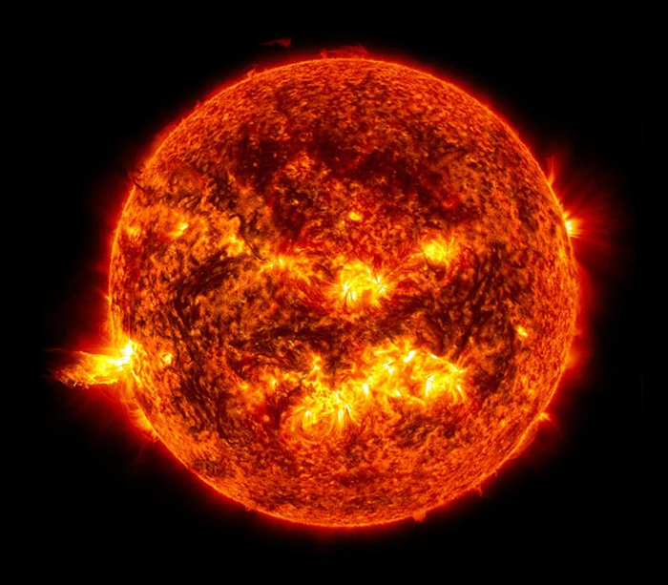

**Figure 2.25**. Photograph showing the dynamic surface of our normal star, the Sun. (NASA)

### Forming Stars from Nebulae

On human timescales, stars take a very long time to form. For this reason, humanity has never observed the entire birth process of a star. Instead, humanity has observed numerous stars at diﬀerent stages of formation and development. Based on these observations and our understanding of the laws that govern nature, humanity has developed an extensively-tested scientiﬁc explanation that describes how stars and planets form. This scientiﬁc theory (nebular theory) successfully explains the observed attributes of nebulae; normal, giant, and mini stars; and planets.

#### From Nebula to Proplyd

Nebulae are huge, highly disordered, thin clouds of mostly hydrogen (92%) and helium (8%) gas, plus a little rock, metal, and ice dust. Written scripture refers to nebulae as ‘matter unorganized’. In contrast to chaotic nebulae, stars are highly ordered systems. The matter in them is concentrated and layered. Stars are born in nebulae. So, how does stellar order emerge from nebular chaos?

Inside nebulae, two processes oppose each other: gravity and gas pressure. The curvature of spacetime produces gravity, which is strongest where matter is most densely concentrated. In contrast, gas pressure results from the motion-induced collisions of gas particles. Gas pressure strengthens as temperature increases. Gravity increases the density and temperature of nebulae as it pulls matter together, and gas pressure lowers nebular density and temperature as it pushes matter apart. In the absence of gas pressure, nebular collapse would proceed with little resistance. What’s more, in the absence of gravity gas pressure would disperse nebulae.

The ‘tug of war’ between gravity and motion (gas pressure) governs the formation, development, and death of stars. Competition between these governing processes can be dynamic. When one process dominates, nebulae can contract or expand for a time. However, one-sided dominance rapidly wanes because the dominating processes increase the strength of the opposing process. In this way, motion provides the ‘ying’ to gravity’s ‘yang ’, and vice-versa. When imbalanced, lawful interactions between gravity and motion can cause ordered stars to lapse into chaotic transitions. In contrast, balanced interactions produce long stages in which little appears to change. For example, the ‘normal star’ stage is a period when vigorous activity between strenuously opposed gravity and motion produces little moment-to-moment change.

Cool nebulae make ideal stellar nurseries because the gas pressure in them is low. Gravitational collapse inside such nebulae begins when suﬃciently dense regions develop. Within a collapsing nebula, inward-pulling gravity overpowers outward-pushing gas pressure because the increasing density produced by the collapse continuously strengthens gravity. In this way, collapse increases density, which increases gravity, which increases density,… in a self-sustaining cascade that continuously shrinks each collapsing portion of the nebula. Individual nebulae can contain thousands of these collapsing globules. Each globule can produce a solar system.

Although uniform globules collapse to form only a central star, most collapsing globules are clumpy. In these globules, gravitational pull causes the shrinking globule to spin. This rotation accelerates as collapse proceeds, just like a ﬁgure skater that pulls limbs inward. Spinning globules eventually ﬂatten into a central bulge and surrounding disk, much like a blob of pizza dough ﬂattens when spun overhead. Eventually, the central bulge becomes a star, and planets form in the surrounding protoplanetary disk (proplyd for short). More on planet formation later. **Figure 2.26** shows a collapsing globule and the proplyd it produces.

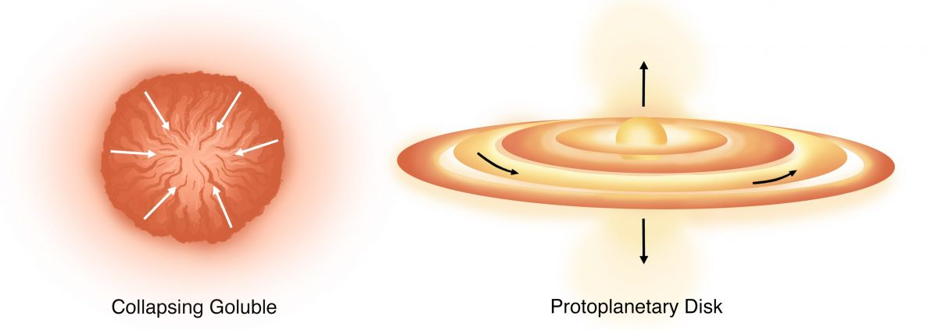**Figure 2.26**. Cartoons showing the early stages of solar system formation—in which a proplyd forms from a collapsing globule. Most of the material in the proplyd becomes part of the growing central star. Proplyd collapse and motion produce the polar outflow jets.

(Proplyd formation, Author illustration, created as a work for hire by Eden Platt. Licensed as CC-BYSA-3.0.)

#### Fusion Fuels Stars and Makes New Matter

During the extended period of gravitational dominance that drives globule collapse, ever-increasing density produces ever-higher pressures and temperatures. This causes atomic nuclei to collide with increasing energy, and these collisions increasingly resist gravitational collapse. When rising temperatures at the dense center of the globule reach ~15 million degrees, collisions become suﬃciently intense to overcome proton-proton repulsion, and nuclear particles fuse. This process, called nuclear fusion, forms elements with heavier nuclei by joining lighter nuclei.

In the cores of normal stars, individual protons of hydrogen nuclei combine to form helium nuclei. In this process, ~1% of the matter (m, mass) becomes a tremendous amount of energy (E). Einstein’s famous equation, E=mc2, expresses this conversion (c is the speed of light and c2is about 10 billion). This equation is an incredibly concise and quantitatively precise way to communicate these truths: energy and mass (matter) are diﬀerent forms of the same thing, matter is tremendously condensed energy, and converting even minuscule amounts of mass produces huge amounts of energy.

The energy produced during fusion fuels stars like our Sun. In case you’re interested, the energy that produces sunlight takes ~100,000 years to reach the Sun’s surface and another 8.3 minutes to reach your skin. So the next time you notice the Sun, contemplate that journey and consider expressing gratitude for the annihilated matter that produces its light. Energy from the Sun has played an essential role in Earth’s habitability since our solar system formed ~4.5 billion years ago, and thankfully the Sun has suﬃcient nuclear fuel to continue warming Earth’s surface for another ~5 billion years.

#### Inside the Forming Star

Those things aside, let’s deepen our understanding of star formation by focusing once again on the collapsing proplyd. Recall that gravitational collapse inside the central bulge produces the ever-higher temperatures and pressures that eventually fuse atomic nuclei. The initiation of fusion marks the beginning of the transition that produces a normal star. If the central bulge is too small and cold to initiate fusion, no star forms. Instead, the collapsing bulge produces a brown dwarf, a kind of huge Jupiter.

In bulges that produce stars, the energy released by early fusion rapidly increases gas pressure in the core. This causes the star to expand explosively. As this expansion proceeds, decreasing temperature and gas pressure cause fusion to cease. Eventually, diminishing temperature and gas pressure allow collapse to begin again, which repeats the earlier steps. In this way, opposition between gravity and fusion-generated gas pressure produces ever-dampening sequences of collapse, fusion, expansion, cooling, collapse, and so on. Eventually, balance develops between gravity and gas pressure and the chaotic transition initiated by fusion gives way to a new, stable state. We call this state a normal star.

Of course, other factors such as the in-falling of matter from the nebula aﬀect this process. Even so, opposition between gravity and fusion ensure eventual stability. Did you catch that important idea? Opposition between gravity and fusion-fueled gas pressure ensures that, eventually, a stable normal star will emerge from the cyclic instabilities associated with star birth. Said another way, gravity and fusion govern the production of the ordered normal-star state from the disordered globule state. Said a fourth way, natural processes cause ordered stars to spontaneously emerge from chaotic nebula.

This reality is also expressed in written scripture. Said an ancient prophet, ‘there can be no creation—no stars, no Earth, no humans—without lawful opposition’ (2 Nephi 2). And so it is. As we continue our journey together, we’ll discover that lawful self-assembly produces all ordered natural states—from dogs to diamonds and planets to primates. Before proceeding, we invite you to pause and ponder this profound perspective.

#### How Normal Stars Form and Develop

So, now you know: all normal stars, including the Sun, are continuous nuclear explosions contained by the balanced inward pull of gravity. What’s more, collapsing globules become normal stars when stellar fusion stabilizes and die when lack of fuel causes fusion to cease. **Figure 2.27** illustrates the sequence of states and transitions that produce normal stars from nebulae. Relative to the lifetimes of normal stars (which extend from a few hundred thousand to trillions of years), the transition from disordered nebulae to ordered normal stars is relatively short. On average, the transition from globule collapse to stable hydrogen fusion occupies just ~0.1% of a star’s lifetime.

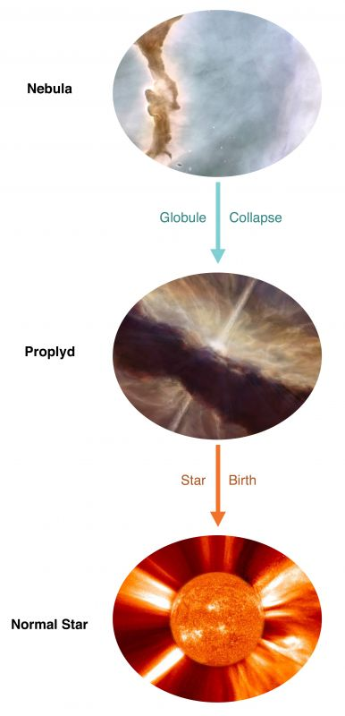

**Figure 2.27**. Illustrations showing the states (images) and transitions (arrows) that produce normal stars from nebulae.

(Forming normal stars, Author illustration, created as a work for hire by Eden Platt using these images: Orion nebula, NASA, public domain; Proplyd, Author illustration, created as a work for hire by Temperance Davis; Sun, NASA, public domain. Licensed as CC-BY-SA-3.0. )

#### Mass Determines Behavior

The amount of matter in stars determines most stellar characteristics, including the nature and magnitude of opposing forces during star birth, life, and ‘death’. For example, mass increases ‘gravitational pull’ (spacetime curvature), which increases the rates of stellar fusion and fuel consumption, which in turn produces hotter stars that live shorter ‘lives’. For these reasons, high-mass stars are hotter, more blue, and live shorter lives than their low-mass counterparts, which are cooler, more red, and live longer lives.

To those unfamiliar with stars, this inverse relationship between mass and lifetime can appear counterintuitive. For example, intuition can suggest that massive stars should live longer lives because they have more fuel. Understanding that massive stars burn fuel much faster than low-mass stars resolves this apparent discrepancy.

Mass also aﬀects the size and brightness of normal stars. Both size and brightness result from emergent balances between energy produced in stellar cores and energy radiated from stellar surfaces. When radiated energy exceeds fusion, stars shrink and dim. Conversely, when interior energy exceeds radiated energy, rising temperature causes stars to expand and brighten. For this reason, high-mass stars are brighter and larger than low-mass stars.

As you can see, mass determines the nature of normal stars by controlling the dynamic equilibrium between gravity and gas pressure.

## Observational Evidence

Humanity’s ever-expanding ability to make telescopic and other observations provide numerous opportunities to test humanity’s scientiﬁc understanding of star formation and development. Signiﬁcantly, these observational tests have been unable to falsify nebular theory. As a result, humanity has tremendous conﬁdence in the theory. Said diﬀerently, although there are many details to explore, the basic processes that create stars and planets are ﬁrmly established.

**Figure 2.28** shows two nebulae where stars and their planetary systems are currently forming. The Orion Nebula lies ~1350 light years from Earth, is ~25 light-years across, and represents the largest nearby star-forming region. Importantly, nebular theory predicted the shapes, ages, and other characteristics of Orion’s proplyds long before humanity could photograph them. In addition to their beauty, recognize that these images are actual photographs of stars and solar systems in the process of forming.

The Eagle Nebula lies ~7000 light-years from Earth and likewise contains thousands of forming solar systems. Energetic, newly-formed stars have blown away much of the original gas. However, in places like the ‘Pillars of Creation’, newly forming solar systems protect spires of gas in much the same way as a shadow protects frost from the Sun.

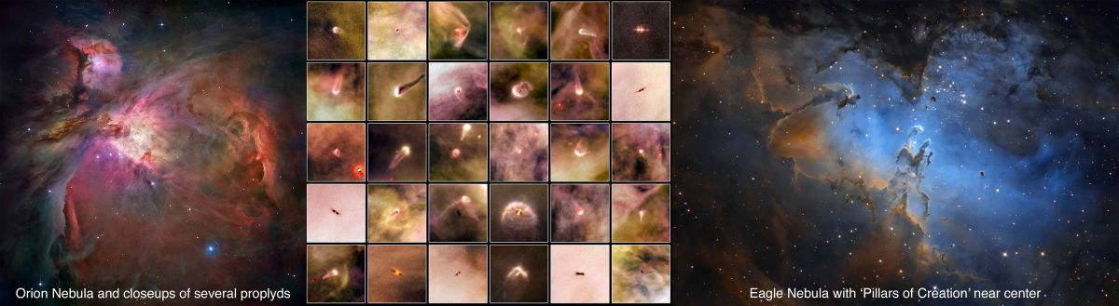

**Figure 2.28**. **Upper**. Photographs of nebulae and proplyds. (NASA photos)

Isn’t it amazing to live when humanity is able to directly observe the formation of new stars, planets, and species?! (More on planets and species later.) Right now, in The Ongoing Creation in which we live, God is ‘pouring out knowledge about the physical world’, including through those who dedicate their lives to studying ‘things above the Earth and beneath the Earth’ (Daniel 12, John 16, D&C 88).

Before proceeding, consider what learning about stars has taught you about science. Do you believe that scientiﬁc discoveries are inspired? Do you believe that science is moving humanity toward an ever-more-correct understanding of how nature formed, developed, and functions? How would you characterize your perspective? Are you eagerly committed to scientiﬁc discoveries? interested but distrustful? purposefully indiﬀerent? disdainfully dismissive? or something else entirely? Typically, your attitude as a disciple toward scientiﬁc scholarship is a keen indicator of your commitment to using physical reality (observation) as an essential test for explanations of nature (interpretation).

Read this online at <https://books.byui.edu/from_atoms_to_humans/28_a_star_is_born>