# 3.18 A Rocky Start

Learning Objectives: • Understand and be able to identify each of the following: accretion, diﬀerentiation, meteorite, undiﬀerentiated meteorite, diﬀerentiated meteorite, iron meteorite, stony meteorite, stony-iron meteorite; and components of habitability—magnetic ﬁeld, rocky mantle and crust, liquid hydrosphere, gaseous atmosphere, biosphere, and Moon. • Describe how accretion and diﬀerentiation produced the components of habitability. Also, describe how each component supports habitability.

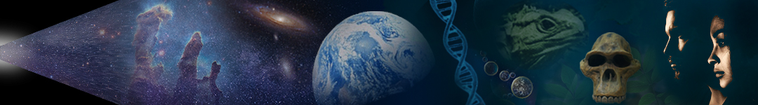Dr. Dan Moore and Dr. Brian Tonks, Geology and Physics Departments, BYU-Idaho

The most erroneous stories are those we think we know best—and therefore never scrutinize or question. —Steven Jay Gould

## Learning Objectives:

* Understand and be able to identify each of the following: accretion, diﬀerentiation, meteorite, undiﬀerentiated meteorite, diﬀerentiated meteorite, iron meteorite, stony meteorite, stony-iron meteorite; and components of habitability—magnetic ﬁeld, rocky mantle and crust, liquid hydrosphere, gaseous atmosphere, biosphere, and Moon.
* Describe how accretion and diﬀerentiation produced the components of habitability. Also, describe how each component supports habitability.

News ﬂash: We live on a habitable planet. Many take this for granted. However, an increasingly detailed study of solar systems suggests that planets, where lawful processes produce and nurture complex life, are relatively rare.

What’s more, early Earth was a very diﬀerent place than our modern garden home, as illustrated in **Figure 3.24**. In fact, Earth has been habitable by animals for only the last ~14% of its existence. During Earth’s infancy, natural processes produced the foundations of Earth’s habitability. These processes formed Earth’s magnetic ﬁeld, rocky mantle and crust, liquid hydrosphere, gaseous atmosphere, and moon. As we’ll discover, interactions between these component systems eventually made Earth habitable.

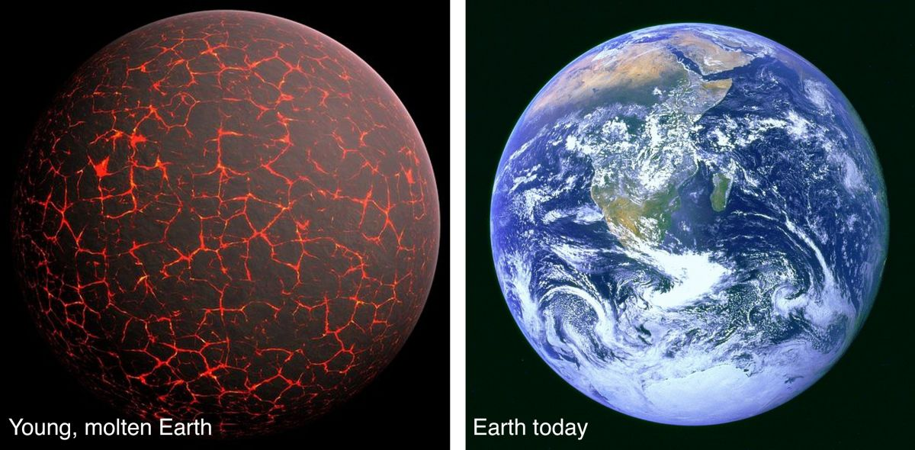

**Figure 3.24**. Illustration of the young molten Earth, and a photo of Earth today.

(Earth comparison, Author illustration, created as a work for hire by Eden Platt using these images: Early Earth, Pixabay, https://bit.ly/3xs 0ar8, CC0; Blue Marble, NASA, https://bit.ly/3LV84NL, public domain. Licensed as CC-BY-SA-3.0.)

## Early Solar System Solids

Earlier we learned that our Solar System formed from a protoplanetary disk like the one in **Figure 3.25**. Our developing proplyd attracted matter from the surrounding nebula. This matter became superheated when it ‘struck’ our proplyd. This heating vaporized most preexisting solids and reset most radioactive clocks. Subsequent cooling then allowed the ﬁrst solids in our Solar System to form ([**Figure 3.23**](https://books.byui.edu/content_images/from_atoms_to_humans/Figure_3_23.jpg)). The ages of these materials indicate that our proplyd formed ~4.57 Bya.

The Sun records the composition of our proplyd. Our proplyd consisted mostly of hydrogen and helium gas, plus minor amounts of numerous other elements and molecules. In the proplyd, heavy elements like iron, magnesium, and silicon combined with oxygen to form dust-sized grains of rock, and elements like iron and nickel formed small grains of metal. The warmest regions of the proplyd were near the growing star. Farther from the sun (beyond the frost line) the proplyd was cool enough for water, methane, and other molecules to form small ice grains. Thus, the proplyd consisted of gas and dust, with rock and metal dust distributed uniformly and ice dust concentrated beyond the frost line.

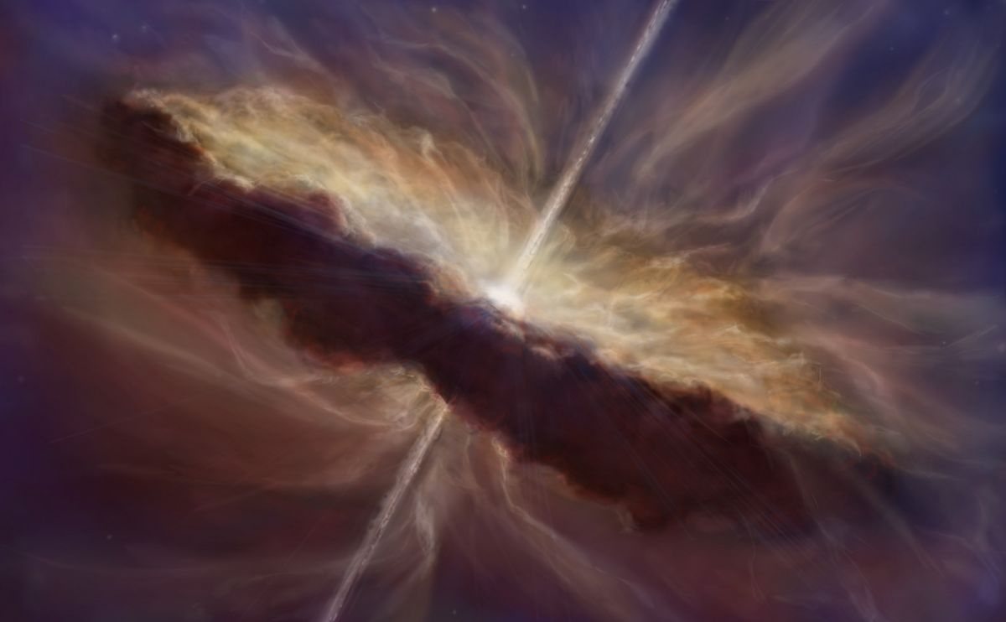

**Figure 3.25**. Illustration of our Solar System during the early proplyd stage.

(Proplyd forming, Author illustration, created as a work for hire by Temperance Davis. Licensed as CC- BY-SA-3.0.)

## Accretion

Recall that accretion is the incremental growth process that produces planetary bodies by collision of orbiting solids. Through accretion, dust in our proplyd formed larger objects—ﬁrst pebbles, then rocks and boulders, and eventually asteroids, planets, and comets. [**Figure 2.42**](https://books.byui.edu/content_images/from_atoms_to_humans/Figure_2_42.jpg)illustrates the period when accretion produced planets in our Solar System.

To date, humanity has been unable to falsify the scientiﬁc theory (nebular theory) that explains how planetary bodies in our Solar System formed. Why? Because this theory explains the characteristics of our Solar System very well. Even so, humanity continues to reﬁne our understanding by studying planetary systems near and far. In addition to the ordered attributes we explored earlier, nebular theory explains the origin of the gas giant planets and their moons, the development of comets and asteroids, and the cratered surfaces of airless inactive bodies like the Moon and Mercury.

These heavily cratered surfaces record the ﬁnal accretionary collisions that formed these bodies. In contrast, the lack of craters on bodies such as Earth and Venus record their continual resurfacing by geologic activity. Although craters are rare on Earth today, they were common in their youth. At that time, Earth’s surface looked similar to the Moon’s surface today. Planetary bodies in our Solar System record collisions of all sizes. Several planetary bodies, including Earth, record colossal impacts between large bodies. Our Moon formed from such collisions.

After the planets formed, rates of collisions decreased over the next ~500 My as the planets swept up most of the solids near their orbits. Later gravitational interactions (mostly with Jupiter) continued scattering debris into the paths of the planets. The process of accretion continues today, but at a tremendously low rate. Presently, Earth accretes only ~50,000 tons of new solid matter each year. So the next time you see a ‘shooting star’, remember that accretion is real and that you live in The Ongoing Creation of Earth.

In recent decades, humanity has developed the ability to observe planets around other stars. To date, astronomers have observed several thousand such planets, and with improved telescopes, the number will soon reach several hundred thousand. Observing the attributes of these planetary systems allows humanity to test and further develop nebular theory. In the process, human understanding of how planetary systems form is progressing line upon line as we upgrade from preparatory truth to preparatory truth—just as it must if we are ever to have a perfect understanding of how planets and their systems form. Isn’t it cool that humanity understands so much about how solar systems and planets form, and that we’re on the verge of discovering so much more?!

## Diﬀerentiation

As accretion progressed, planetary bodies formed from available solids. Inside the frost line, these bodies contained ﬁnely intermixed rock and metal. Farther out they consisted mostly of ices, with minor intermixed rock and metal. Where collisions and radioactive decay provided suﬃcient heat (mostly near the Sun), dense metal inside primitive planetesimals separated from less-dense rock in a process called differentiation.

This density separation or chemical ‘unmixing’ produced layered planetary bodies with metallic cores surrounded by rocky mantles and crusts, as illustrated in **Figure 3.26**. Where conditions were favorable, diﬀerentiation also produced solid ‘ice-spheres’ (cryospheres), liquid hydrospheres, and gaseous atmospheres. Far from the Sun, where comets formed, diﬀerentiation was relatively uncommon because heat from collisions and radioactivity were less abundant.

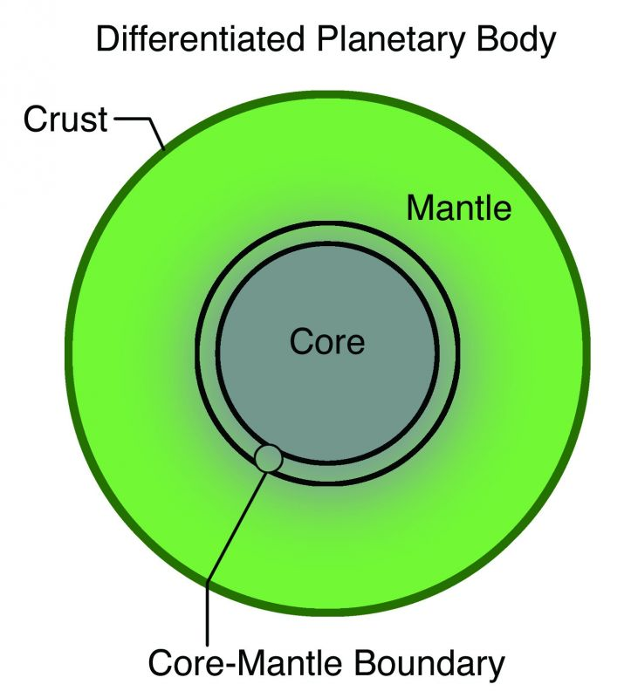

**Figure 3.26**. Cross-section of a diﬀerentiated planetary body—with a metallic core, rock mantle, and rocky crust.

(Diﬀerentiated asteroid, Author illustration, created as a work for hire by Eden Licensed as CC- BY-SA-3.0.)

In the Asteroid Belt, Jupiter’s inﬂuence prevented planetesimals from forming a planet. As a result, the Asteroid Belt preserves the building blocks of planets, including both primitive (undiﬀerentiated) and evolved (diﬀerentiated) planetary bodies. Through the eons, gravitational interactions have caused rocks from the asteroid belt (and less commonly from other bodies like Moon and Mars) to collide with Earth. We call these space rocks meteorites.

Basic meteorite types are shown in **Figure 3.27**. Undifferentiated meteoritesare space rocks composed of primitive solids that formed in the early Solar System. They consist of ﬁnely intermixed rock and metal. In contrast, differentiated meteoritesare space rocks that formed as part of the crust, mantle, or core of a planetary body. We refer to those that originated in a core as iron meteorites, those that formed at a core-mantle boundary as stony-iron meteorites, and those that formed in a mantle or crust as stony meteorites.

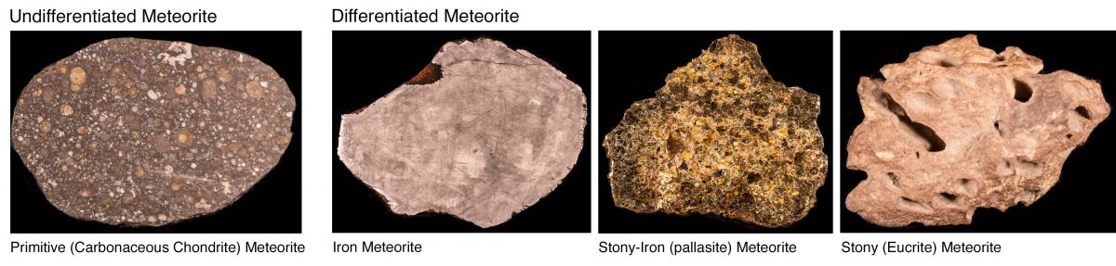

**Figure 3.27**. Photos of thumb-to-hand-sized undiﬀerentiated and diﬀerentiated meteorites. Each of these meteorites fell to Earth after being ejected from their parent asteroid by collisions.

(Meteorites, Author illustration, created as a work for hire by Eden Platt using author photographs. Licensed as CC-BY-SA-3.0.)

Undiﬀerentiated meteorites are the most common type to collide with Earth today, likely because a relatively recent collision fragmented an undiﬀerentiated asteroid. Undiﬀerentiated planetesimals are the starting material from which the layered (diﬀerentiated) planetesimals and planets formed. Diﬀerentiated meteorites record abundant information about their parent bodies. For example, iron meteorites indicate that they formed inside asteroids similar in size to those found in the Asteroid Belt today.

## Forming the Components of Earth’s Habitability

Earth—like Mercury, Venus, and Mars—is a fully diﬀerentiated planet. Diﬀerentiation is critically important to the habitability of Earth. Observations of planetary materials indicate that Earth’s layers (metallic core, rocky mantle and crust, liquid hydrosphere, and gaseous atmosphere) originated no later than the Moon-forming giant impact at ~4.51 Bya, about 30 My after Earth formed.

Heat from accretion, radioactivity, diﬀerentiation and the formation of the Moon made early Earth incredibly hot. This heat generated at least three periods in which Earth’s surface consisted of a deep magma ocean (**Figure 3.24**). This ﬁery birth laid the foundation for Earth’s eventual habitability because it produced Earth’s component systems—its Moon, magnetic ﬁeld, rocky mantle and crust, solid ice-sphere (cryosphere), liquid hydrosphere, gaseous atmosphere, and biosphere. In time, energy from Earth’s interior and the Sun drove interactions between these systems. These interactions produced Earth’s climate system and made Earth habitable.

### Our Magnetic Field

Earth’s core makes up more than half of its radius and consists mostly of iron and nickel (plus a few percent of light elements like silicon, carbon, and sulfur and small amounts of other metals like platinum and gold). The core contains a solid inner sphere surrounded by a thick layer of molten metal. These metallic layers and Earth’s spin produce a **magnetic ﬁeld** that surrounds our planet in a protective shield. Without this shield, solar radiation would strip away Earth’s atmosphere and make Earth uninhabitable. Incidentally, the auroras (the northern and southern lights) occur when intense solar radiation partially penetrates Earth’s magnetic ﬁeld and collides with molecules in the upper atmosphere.

So, if you’re a fan of science ﬁction and long to zip through the galaxy in a spaceship protected by an invisible force ﬁeld, you’re in luck. At this very moment, you’re traveling on spaceship Earth at immense speed through the Solar System and galaxy—all the while protected by Earth’s mostly-invisible magnetic ﬁeld. Reality is so cool, isn’t it?!

### Rocky Mantle and Crust

Earth’s core is surrounded by two layers of solid rock, the **crust** and **mantle**. By volume, Earth is ~1% crust, ~84% mantle, and ~15% core. Crustal rock is less dense than mantle rock, which is why the crust forms our planet’s surface. **Figure 3.28** shows a piece of Earth’s primitive crust.

As you know, the slow ﬂow of solid rock drives tectonic changes like volcanoes, earthquakes, and plate motion. Surface cooling and internal heat drive this slow convective ﬂow. Earth’s tectonically active crust and mantle support habitability by creating continental and oceanic crust, forming mountain ranges and sedimentary basins, producing volcanoes, and moderating Earth’s climate. More on this later.

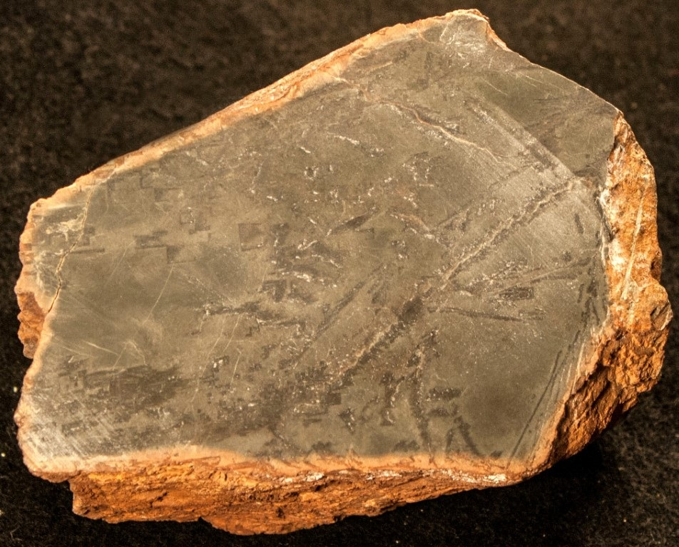

**Figure 3.28**. A palm-sized piece of ancient crust from northwestern Australia.

(Komatiite, Author photograph. Licensed as CC-BY-SA-3.0.)

### Hydrosphere and Atmosphere

Outside the crust and mantle lie Earth’s least dense, outermost material layers—the **hydrosphere** and **atmosphere**. Although they represent a tiny fraction of Earth’s mass, these layers play a supersized role in planetary habitability. For example, atmospheric carbon modulates Earth’s climate and liquid water is among the most important requirements for life. Can you think of other important functions? If not, stop breathing and you’ll quickly remember at least one more.

### The Moon

Although our large Moon is not physically connected to Earth, its ‘gravitational’ inﬂuence stabilizes Earth’s tilt. In this way, the Moon protects Earth from the tilt-altering gravitational tugs of giant planets like Jupiter, which would otherwise drastically diminish the habitability of Earth by cyclically producing huge seasonal variations in important climate variables like temperature.

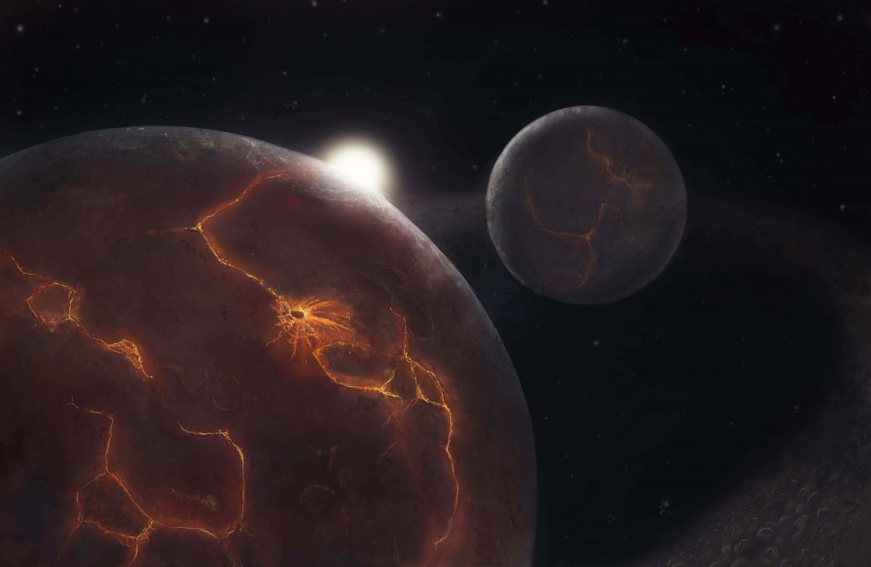

**Figure 3.29**. Early Earth and Moon shortly after the giant impact. Note the arc of material from which the Moon is forming by accretion.

(Moon forming after giant impact(s), Author illustration, created as a work for hire by Temperance Davis. Licensed as CC-BY-SA-3.0.)

**Figure 3.29** shows the Moon forming around Earth at ~4.51 Bya. The attributes of Moon and Earth are best explained by giant impacts between early Earth and several large planetesimals. This ‘giant impact’ hypothesis was ﬁrst developed in the 1970s by William Hartmann and Don Davis following extensive study of the Moon and its materials. By the mid 1990s, competing hypotheses for the formation of Moon had been falsiﬁed. Today, although there is much still to learn about the Moon, the giant impact explanation is a scientiﬁc theory because it has withstood all observational tests.

### Biosphere

As we’ll discuss later, living things are complex organic systems that persist, act with purpose, reproduce, and evolve. After Earth cooled suﬃciently, single-celled organisms like those in **Figure 3.30** developed and dominated. Earth’s **biosphere** consists of all living things.

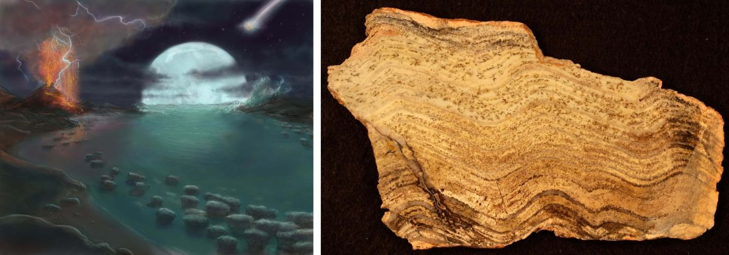**Fig 3.30**. Painting of early Earth showing knobby bacterial pillars (stromatolites) along a shallow coastline (left), and a palm-sized slice of Earth’s oldest known stromatolite fossil (from Strelley Pool, western Australia). The wavy layers of sediment in the ﬁst-sized stromatolite sample were trapped by bacterial mats 3.4 Bya.

(Early life, Author illustration, created as a work for hire by Eden Platt using Early Earth image created as a work for hire by Temperance Davis and author Licensed as CC-BY-SA-3.0.)

Many individuals consider the biosphere as a passenger on spaceship Earth, taking what it needs from Earth but having little impact on the planet. Not true! The biosphere has had tremendous impact on Earth and has in turn been tremendously changed by it. For example, the atmospheric oxygen required by animals was ﬁrst produced by the biosphere (by single-celled photosynthetic organisms). The progressive emergence of modern levels of atmospheric oxygen, which revolutionized Earth, forms an important chapter in the development of Earth’s habitability.

To summarize, planets like Earth form within protoplanetary disks as small solid particles aggregate into larger bodies. Our Sun and its system of planets formed from a proplyd between ~4.56 and ~4.54 Bya.

During and following the accretion of Earth, diﬀerentiation produced Earth’s component systems. In time, complex interactions between these systems made Earth habitable. So, if you haven’t expressed gratitude recently for Earth’s magnetic ﬁeld, mantle, crust, hydrosphere, atmosphere, or Moon, consider doing so now. Your existence on Earth would be impossible without them.

## **ForThe Curious**

From Dust to Life: The Origin and Evolution of Our Solar System by Chambers and Mitton (2013, Princeton University Press).

How to Build a Habitable Planet: The Story of Earth from the Big Bang to Humankind by Langmuir and Broecker (2012, Princeton University Press).

Read this online at <https://books.byui.edu/from_atoms_to_humans/318_a_rocky_start>