# 3.19 A Breath of Fresh Air

Learning Objectives: • Describe the oxygen content and basic character of Earth’s atmosphere during these states and the transitions that separate them: State 1 - Oxygen Free (early Precambrian), 1st Transition (mid-Precambrian), State 2 - Oxygen Poor (The Boring Billion, late Precambrian), 2nd Transition (late Precambrian), and Modern State - Oxygen-rich (Phanerozoic). • Describe how each transition cooled climate suﬃciently to produce a ‘Snowball Earth’ episode.

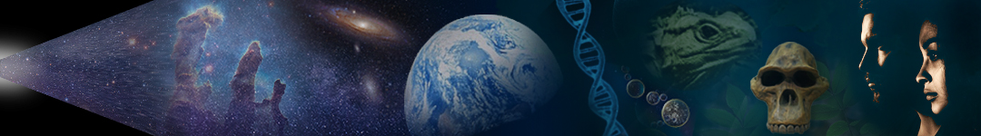

Dr. Dan Moore and Dr. Brian Tonks, Geology and Physics Departments, BYU-Idaho

The history of any one part of the Earth, like the life of a soldier, consists of long periods of boredom and short periods of terror. —Derek V. Ager

## Learning Objectives:

* Describe the oxygen content and basic character of Earth’s atmosphere during these states and the transitions that separate them: State 1 - Oxygen Free (early Precambrian), 1st Transition (mid-Precambrian), State 2 - Oxygen Poor (The Boring Billion, late Precambrian), 2nd Transition (late Precambrian), and Modern State - Oxygen-rich (Phanerozoic).
* Describe how each transition cooled climate suﬃciently to produce a ‘Snowball Earth’ episode.

Even though many take Earth’s modern habitability for granted, most are fascinated to discover the intricately lawful processes that made Earth habitable. After all, who isn’t interested in what allows them to exist.

When it comes to habitability, Earth’s atmosphere takes center stage. Not only does it hold life-giving oxygen for animals like humans, but it plays a central role in Earth’s climate system. Interactions between Earth’s systems determine the abundance of atmospheric oxygen and carbon, as illustrated in **Figure 3.31**. We refer to interactions and processes that add material to the atmosphere as sources and those that remove material as sinks.

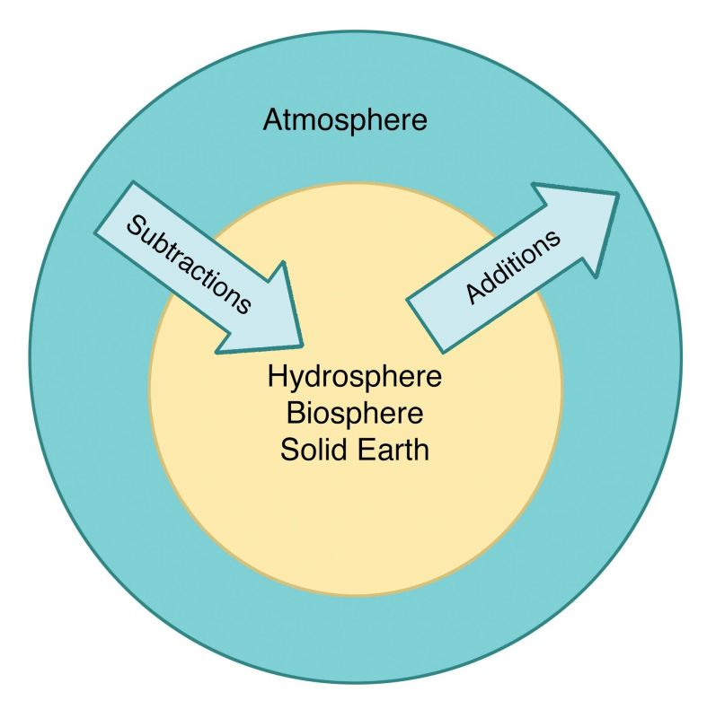

**Figure 3.31**. Cartoon showing how interactions between systems change atmospheric composition by adding or removing molecules like free oxygen (O2) and carbon dioxide (CO2).

(Composition of Earth’s atmosphere, Author illustration, created as a work for hire by Eden Platt. Licensed as CC-BY-SA-3.0.)

The composition of Earth’s modern atmosphere is not normal for a terrestrial planet. If the atmosphere were in equilibrium with solid Earth, it would contain almost no free oxygen. It would also contain noxious gases such as methane, carbon monoxide, and carbon dioxide. Earth’s modern atmosphere lies far from equilibrium, in large part because living things constantly add free oxygen to the atmosphere. If these organisms stopped producing oxygen today, Earth’s atmosphere would become ‘unbreathable’ in just a few thousand years.

Ancient Earth materials record that our modern oxygen-rich atmosphere developed from an oxygen-poor atmosphere, which itself developed from an oxygen-free state. **Figure 3.32** illustrates the durations and oxygen concentrations of these three states and the two transitions that separate them. Each of these states persisted for a very long time. The ﬁrst state lasted ~2 By, the second ~1 By, and our modern state has existed since ~650 Mya or about the last 14% of Earth’s history. Moreover, the transitions that separate these atmospheric states were not rapid. The ﬁrst transition took ~600 My and the second ~200 My. Both of these transitions caused major changes in the types and abundance of living things. For example, the ﬁrst transition made much of Earth’s surface uninhabitable to certain single-cell organisms (anaerobes), and the second transition coincides with the emergence of multicellular animals.

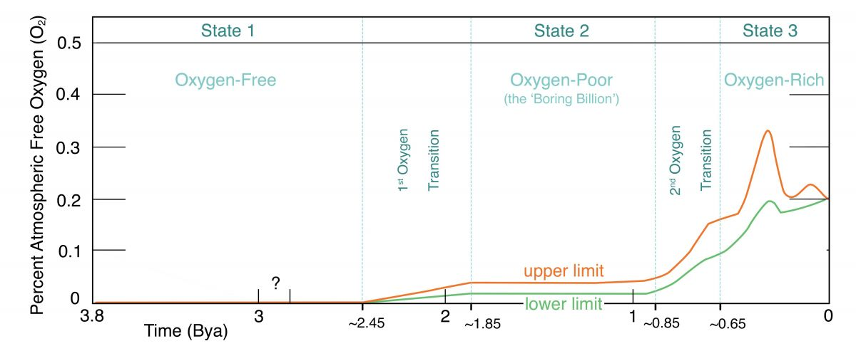

**Figure 3.32**. Plot of atmospheric oxygen levels through time showing major states and transitions.

(Atmospheric oxygen through time, Author illustration, created as a work for hire by Eden Platt after Heinrich Holland plot, https://bit.ly/37BTe Nq, CC-BY-SA-3.0. Licensed as CC-BY-SA-3.0.)

## State 1: An Oxygen-Free Atmosphere

The foundations of Earth’s present atmosphere emerged ~4.51 Bya from gases released during the giant Moon-forming impacts. Then, gases released by volcanic activity and impacts continued to source our developing atmosphere. Thus, Earth’s present atmosphere and hydrosphere, formed mostly from gases, released from molten rock. What was the nature of this early atmosphere?

Earth’s **state 1** atmosphere was likely similar to the present atmospheres of Venus and Mars. These atmospheres consist mostly of CO2 (~96%), with minor nitrogen (~3.5%) and argon (~1%), and trace amounts of other gases. They contain essentially no free oxygen. The abundant and eﬀective greenhouse gases in Earth’s early atmosphere eﬃciently trapped heat from solar radiation. This heat kept Earth’s surface warm during the Sun’s early years when it produced about one-third less energy than today.

Initially, Earth’s surface and atmosphere were too hot for oceans to form. During this period, the oceans existed mostly as water vapor (steam) in the atmosphere. However, once Earth’s surface cooled below the boiling point of water, rain fell, and fell, and fell… for centuries, perhaps for millennia. Earth’s oceans formed as rainwater ﬂowed into and ﬁlled the ocean basins. Earth materials provide suggestive evidence for liquid surface as early as ~4.4 Bya, but deﬁnitive evidence for oceans doesn’t appear until ~3.7 Bya. These earliest oceanic sediments (from southeastern Greenland) contain chemical clues that may indicate the presence of life. But the earliest conclusive evidence for life appears ~3.43 Bya in what is now northwestern Australia. These fossils consist of layered sediment trapped by bacterial mats (like those shown in [**Figure**](https://books.byui.edu/content_images/from_atoms_to_humans/Figure_3_30.jpg)[**3.30**](https://content.byui.edu/file/fdc3a775-634d-4ff2-b4e9-d1538d36a16e/1/Text/Topic3.4.pdf)). These organisms thrived on a planet without persistent free oxygen.

## Transition to the Second State: An Oxygen-Poor Atmosphere

By ~3.4 Bya, single-celled organisms had begun harvesting sunlight to power their lives. However, modern oxygen-producing photosynthesis did not emerge until two primitive photosynthetic processes combined in cyanobacteria at ~2.7 Bya. These modern photosynthesizers used carbon dioxide and water to produce energy and make the materials that formed their single-celled bodies. In addition, they released a poisonous byproduct—the O2 gas that caused Earth’s ﬁrst oxygen transition.

Earth’s **1st Oxygen Transition** is sometimes referred to as the ‘Great Oxidation Event or ‘First Oxygen Revolution’. During this transition, newly-abundant oxygen-producing organisms caused atmospheric free oxygen to rise to ~1% of modern levels. This transition occurred during the middle Precambrian and lasted ~600 million years.

If you look closely at ‘pond scum’, you can observe the oxygen-ﬁlled bubbles produced by modern descendants of the early photosynthesizers (cyanobacteria) that produced Earth’s ﬁrst oxygen revolution. What’s more, descendants of these early photosynthesizers are found inside plant cells. In biology class, you called these descendants ‘chloroplasts’. Did you know that even today, chloroplasts use their own DNA to replicate independently inside their host plant cells? Clearly, humanity owes cyanobacteria two tremendous debts. Not only do they produce most of the oxygen we breathe, but they also power plant cells. So, the next time you encounter ‘pond scum’, be sure to thank those organisms. Without them, a breath would kill you and plants would not exist.

Now, back to oxygen. The highly-reactive oxygen (O2) produced by photosynthesizers altered Earth’s surface, cooled the planet and changed the history of life. Recall that most early organisms thrived in O2-free environments. Thus, the generation of free oxygen made vast regions of Earth’s surface uninhabitable to most early single-celled organisms. In this way, the Great Oxidation Event caused what is likely Earth’s largest mass extinction. In the aftermath of this mass die-oﬀ, biological innovations produced organisms that could tolerate oxygen poison—and later, produced organisms that thrived in oxygen-rich environments. These complex, single-celled oxygen lovers, known as eukaryotes, emerged by ~2.1 Bya. Notably, all animals and plants consist of eukaryotic cells. This is why your body needs O2 to survive.

In addition to irrevocably changing the trajectory of life, atmospheric free-oxygen changed Earth’s surface forever, both on land and in water. Early O2 destabilized ‘reducers’ like iron, sulfur, and carbon that had been abundant at Earth’s surface for eons. As these reducers combined with oxygen, they formed solid sediments that were removed from Earth’s surface by burial, as illustrated in **Figure 3.33**. For example, dissolved iron had long been stable in Earth’s oceans, but reaction with oxygen caused oceanic iron to precipitate. These iron-oxide-rich sediments accumulated worldwide, producing the banded iron formations that are modern humanity’s main source of iron (**Figure 3.33**).

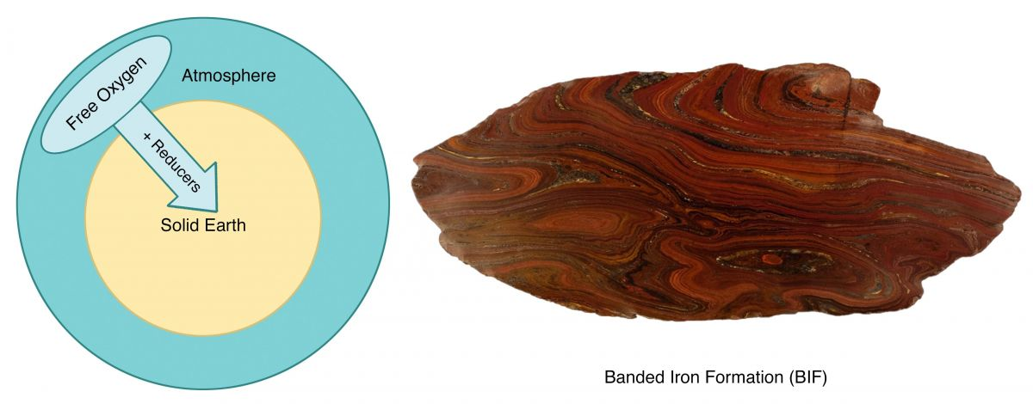**Figure 3.33**. **Left**: Cartoon illustrating how reducers like iron reacted with O2 and were buried as iron-oxide-rich sediment. **Right**: Photo of a head-sized slab of banded iron formation (BIF). Without BIFs, our iron-based civilization could not exist.

(Oxidizing Earth’s atmosphere, Author i l lustration, i l lustration and image created as a work for hire by Eden Platt using an author Licensed as CC-BY-SA-3.0.)

In addition to reacting with iron and other reducers, O2 reacted with atmospheric hydrogen (H2), methane (CH4), and ammonia (NH4) gases. These reactions produced molecules like carbon dioxide (CO2), nitrogen (N2), and water (H2O). As a result, Earth’s ‘state 2’ atmosphere contained mostly nitrogen and carbon dioxide, with trace amounts of other gases like free oxygen.

The oxidation of Earth’s atmosphere converted methane (CH4) to carbon dioxide (CO2). This cooled global climate cooled because carbon dioxide is a much weaker greenhouse gas than methane. This cooling was enhanced by the formation of abundant carbon-bearing rock (limestone and black shale) during this transition. This tremendous cooling produced a rare Snowball Earthepisode. Earth materials produced at this time record the presence of glaciers at sea level at the equator, indicating that most of Earth’s surface was covered by ice. Eventually, volcanic activity re-warmed Earth and ended this ‘snowball’ state—by adding carbon dioxide to the atmosphere.

Later (by ~1.85 Bya) oxygen production by life and oxygen removal by oxidation and burial reached a balance. This allowed free oxygen to stabilize to ~1% of modern levels, which ended Earth’s ﬁrst oxygen transition and initiated Earth’s **state 2** atmosphere. We often refer to this period as the ‘boring billion’ because Earth’s ‘state 2’ atmosphere changed very little over the next ~1 By (**Figure 3.32**). During the boring billion, free-oxygen concentrations were too low for oxygen-loving eukaryotes to build persistent colonies. However, the rise of atmospheric oxygen during Earth’s second oxygen revolution allowed these ‘persistent colonies of eukaryotes’ to begin thriving. You know these cooperating eukaryotic colonies by another name—animals.

## Transition To the Third State: A Modern Oxygen-Rich Atmosphere

Earth’s modern atmosphere contains ~78% nitrogen and ~21% free oxygen, with trace amounts of other gases like carbon dioxide and water. This modern state atmosphere emerged from Earth’s **2nd Oxygen Transition**, which lasted ~200 My (**Figure 3.32**). This transition resulted from a period in which tectonic and biological processes buried enormous quantities of biologic carbon, in the form of dead single-celled organisms.

The shallow seas in which these microorganisms thrived surrounded portions of a dividing supercontinent. The supercontinent Rodinia, which coalesced by ~1 Bya, began dividing ~750 Mya. As Rodinia split apart, the global abundance of coastlines grew. Along these coastlines, river-delivered nutrients allowed oceanic microorganisms to thrive. When these organisms died, they were eﬃciently buried by sediment from the same rivers that had fueled their growth.

Recall that photosynthetic cyanobacteria use the carbon in CO2 and the hydrogen in H2O to build their bodies. In the process they release the O2 gas that is poisonous to them. When cyanobacteria die, this process reverses—free oxygen reacts with their bodies to produce carbon dioxide and water. However, when burial occurs before reacting with oxygen, levels of atmospheric oxygen and the amount of buried carbon rise.

In this way, carbon burial acts as a kind of ‘atmospheric oxygen pump’. Thus, as carbon burial proliferated in the coastlines that surrounded rifting Rodinia, global levels of free oxygen increased and the concentration of atmospheric CO2 fell. Rising oxygen produced our modern atmosphere and facilitated the emergence of animal life, and falling carbon dioxide plunged the planet into a vast global ice age, Earth second Snowball Earthepisode. As before, carbon dioxide released by volcanoes eventually re-warmed the planet and ended the second snowball episode.

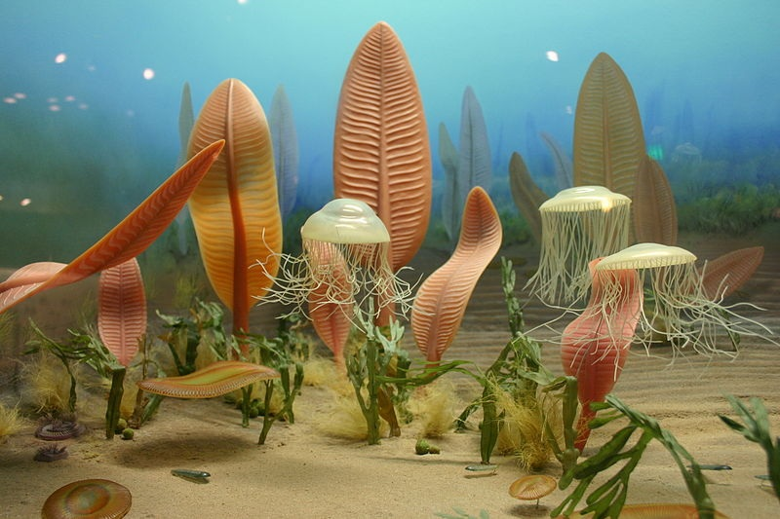

**Figure 3.34**. Illustrated reconstruction of the early animal community known as the ‘Edicaran fauna’. Note the primitive jellyﬁsh in the foreground.

(Ediacaran fauna, Ryan Somma, https://bit.ly/3xgIv5X, CC-BY-SA-2.0.)

As oxygen levels rose during the second transition, early animals like sponges and jellyﬁsh emerged from colonies of communicating eukaryotic cells. The earliest animals did not have eﬃcient ways to circulate oxygen through their bodies. Instead, they relied on the slow movement (diﬀusion) of oxygen from seawater into their cells. However, as oxygen levels rose, more oxygen was available in seawater, and cells could incorporate this energy-giving substance more eﬃciently. As a result, increased oxygen levels allowed the development of larger, thicker bodies. The ﬁrst true community of animals appeared ~580 Mya, shortly after Earth’s 2nd Oxygen Transition. **Figure 3.34** shows these early animals.

Competition among the ﬁrst animals produced organisms with increasing complexity, including sensory organs like eyes and antennae. Then, ~543 Mya multicellular organisms developed the ability to build hard parts using matter extracted from seawater. This development allowed successive animal generations to develop defensive and oﬀensive body parts like shells and teeth. In addition, improved mechanisms for acquiring and moving oxygen (like gills and veins) played important roles in the development of early animal communities. For example, larger mobile animals required ever more eﬃcient ways of acquiring, processing, and distributing oxygen.

The ‘evolutionary arms race’ produced surviving generations of prey with better camouﬂage, more rapid locomotion, and heavier armor. These developments were counteracted by successive generations of predators with stronger jaws, sharper teeth, and better vision. More on the development of life later.

As the discussion above illustrates, the relationship between atmospheric oxygen and life is fascinating. Did you know, for example, that although oxygen fuels animal life it also ensures animal death? Unfortunately, that is a story for another day. For now, remember to delay the death-inducing eﬀects of oxygen by consuming antioxidants …but don’t forget to breathe.

In summary, the oxygen released by cyanobacteria produced Earth’s ﬁrst oxygen transition, and the burial of unoxidized carbon drove the second transition. Both of these transitions spawned global ice ages, and these Snowball Earth episodes ended when volcanic CO2 re-warmed Earth. In these and so many other ways, the emergence of atmospheric O2 beautifully illustrates this important principle: the development of life dramatically alters Earth and the development of Earth dramatically alters life. So interesting, and so cool!

Incidentally, so long as living things are present on Earth’s surface, free oxygen cannot rise above ~30%. This upper limit was reached once in Earth’s history when the ﬁrst true forests emerged ~360 Mya. This episode, which we’ll discuss later, shows up as the large ‘hump’ on the right of **Figure 3.32**.

## **ForTheCurious**

Oxygen: The Molecule that Made the World by Nick Lane (2016, Oxford University Press).

Read this online at <https://books.byui.edu/from_atoms_to_humans/319_a_breath_of_fres>