# 3.21 Mother Earth

Learning Objective: • Describe the development of Earth’s climate (in terms of states, transitions, and speciﬁc carbon sources and sinks) from the mid-Paleozoic greenhouse, through the climate transition that produced the late Paleozoic icehouse, then through the transition that produced the Mesozoic greenhouse, and ﬁnally through the transition that produced the modern Late Cenozoic icehouse.



Dr. Dan Moore and Dr. Brian Tonks, Geology and Physics Departments, BYU-Idaho

Civilization exists by geological consent, subject to change without notice. —Will Durant

## Learning Objective:

* Describe the development of Earth’s climate (in terms of states, transitions, and speciﬁc carbon sources and sinks) from the mid-Paleozoic greenhouse, through the climate transition that produced the late Paleozoic icehouse, then through the transition that produced the Mesozoic greenhouse, and ﬁnally through the transition that produced the modern Late Cenozoic icehouse.

Today, Earth’s climate lies near the cold end of the icehouse state, but rock bodies across the planet record that Earth was in an extreme greenhouse state in the early Cenozoic. These extremely diﬀerent climates become readily apparent when comparing present organisms to those that inhabited western Wyoming during the 50-Mya extreme greenhouse. Today, the area is a cold high desert inhabited by organisms like sagebrush, juniper, rabbits, and antelope. Earlier, this area was hot, humid, and hosted subtropical organisms, which were exquisitely preserved in the sedimentary time capsule of an ancient lake. **Figure 3.39** shows a few of these fossilized organisms, which you can observe in the Visitor’s Center at Fossil Butte National Monument.

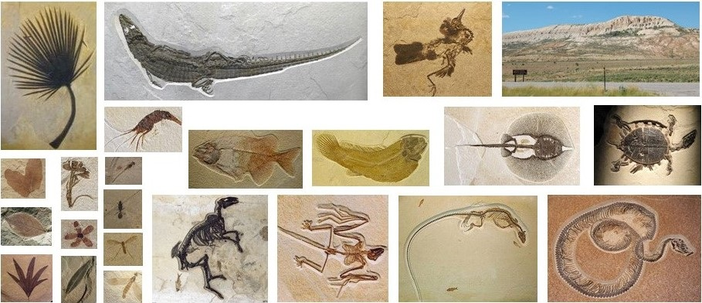

**Figure 3.39**. Photos of exquisitely preserved fossilized organisms that lived in the subtropical climate of western Wyoming ~50 Mya. The upper-right photo shows the cool dry climate of today, and the fossils demonstrate the earlier warm climate.

(Green River formation fossils, Author illustration, created as a work for hire by Eden Platt using images from Arvid Aase, NPS, public domain. Licensed as CC-BY-SA-3.0.)

Palm trees and alligators live in Florida and Costa Rica today, not in Wyoming. In the last 50 My the latitude and elevation of western Wyoming have changed little, but its climate has changed a lot. What’s more, fossils clearly record that subtropical palm trees, alligators, and the like lived year-round in Antarctica during the hottest parts of the early Cenozoic extreme greenhouse. Although astounding, it’s true. This early-Cenozoic extreme greenhouse climate event illustrates what can happen when carbon sources dominate carbon sinks.

As illustrated in **Figure 3.40**, global climate tends towards the upper and lower limits of planetary habitability. At these extremes opposing processes dynamically maintain a fairly constant climate, often for relatively long periods. Today, global climate lies at the cool end of habitability, in the icehouse state. **Figure 3.41** shows the climate states we will use to explore how carbon-transfer events produced Earth’s recent climate history from the mid-Paleozoic to today. Our exploration will provide you with the opportunity to deepen your intuition about the lawful nature of broad-scale transitions between greenhouse and icehouse climate states. Take a moment to correlate the events represented by the two ﬁgures.

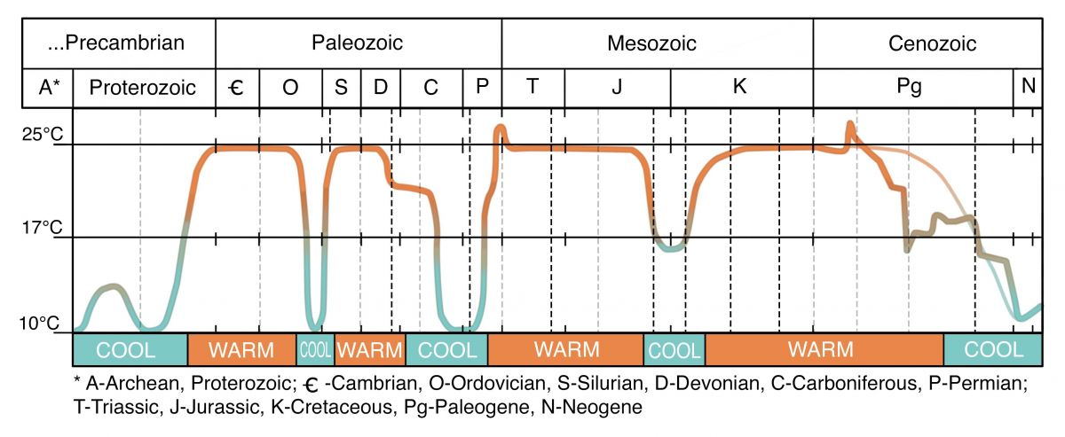

**Figure 3.40.** Broad-scale climate history of Earth. The ﬁgure also shows both the more-detailed and averaged (light gray) cooling paths that produced today’s icehouse Earth. Note that extreme climate states dominate Earth’s climate history.

(Global temperature through time, Author illustration, created as a work for hire by Eden Platt after image by Christopher R. Scotese, https://bit.ly/37DRrY2. Licensed as CC-BY-SA-3.0.)

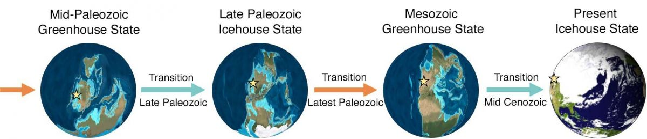**Figure 3.41**. Major climate transitions from the mid-Paleozoic to today.

(Mid-Paleozoic climates, Author illustration, created as a work for hire by Eden Platt and Jordan Barton, maps after purchasing Ron Blakey images. Licensed as CC-BY-SA-3.0.)

## From Greenhouse to Icehouse in the Late Paleozoic

We begin our exploration of Earth’s recent climate history in the mid-Paleozoic, with the emergence of the ﬁrst land plants. Observations suggest that the ﬁrst land plants descended from fresh-water algae. These plants were simple, like some modern mosses. As these plants established a ﬁrm foothold on land, animals followed. The movement of plants and animals from ocean to land opened a new stage in the development of life. It also drastically altered Earth’s climate state.

Early plants were restricted to shorelines because their reproductive cells (spores) needed water. As plants began crowding Earth’s shorelines, competition for sunlight was selected for taller plants with broader crowns. Selective pressures also instigated biological innovations such as strong roots, eﬀective vascular tissues, and supportive wood. These biological innovations produced Earth’s ﬁrst trees.

In the wetland environments where early fern-like trees thrived, dead trees often fell into standing water that contained little oxygen. Normally, the carbon in dead trees is oxidized and returns to the atmosphere as CO2. However, the swamp water common in early forests limited oxygen’s access to much of the carbon in dead trees. As a result, thick deposits of carbon-rich tree matter accumulated in wetland forests. After these deposits were buried, they formed abundant layers of coal and carbon-rich shale.

In this way, forested swamplands promoted the burial of vast quantities of carbon during the late Paleozoic. How do you think this changed Earth’s climate. If you surmised that this event caused global climate to cool and transitioned Earth into an icehouse climate state, you’re right (see **Figures 3.40-3.41**). During this icehouse state, Earth experienced the fourth of its ﬁve large ice ages. (The ﬁrst two ice ages were the Snowball Earth events we discussed earlier, the third ended the early Paleozoic (Ordovician), and we inhabit the ﬁfth ice age; see **Figure 3.40**).

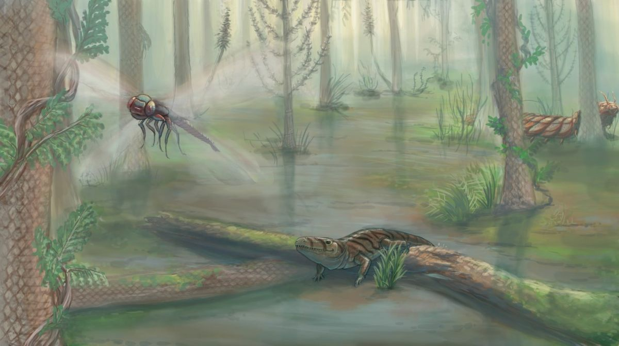

**Figure 3.42**. Painting of a late Paleozoic coastal swampland, showing an amphibian and two huge insects.

(Paleozoic swamp, Author illustration, created as a work for hire by Temperance Davis. Licensed as CC-BY-SA-3.0.)

Not only did carbon burial during the late Paleozoic greatly reduce atmospheric carbon dioxide, but it also caused atmospheric free oxygen to rise to the highest levels ever experienced on Earth (see the oxygen spike in [**Figure 3.32**](https://books.byui.edu/content_images/from_atoms_to_humans/Figure_3_32.jpg)). Soot preserved in sedimentary deposits from this time indicate that these unusually high levels of free oxygen produced frequent and extensive ﬁres in these swampy forests. What’s more, fossils from this time indicated that insects reached their largest sizes. See, for example, the bird-sized dragonﬂy and alligator-sized millipede shown in **Figure 3.42**. The amphibian shown in this ﬁgure is a descendant of Earth’s ﬁrst amphibians. As we’ll explore later, the abundant food and other selective pressures provided by early wetland forests eventually molded shoreline-adapted ﬁshes into Earth’s ﬁrst amphibians.

You might be interested to know that most of the coal that fueled humanity’s Industrial Revolution was deposited in the wetland forests of the mid-to-late Paleozoic (Carboniferous). In the centuries since the Industrial Revolution, humanity has continued extracting energy by burning carbon-based fuels like coal, oil, and natural gas. This has resulted in the extremely rapid return of this long-buried carbon to the atmosphere. More on modern climate warming later.

### More About Carbon Burial

Carbon burial, which produced the icehouse state of the late Paleozoic, is Earth’s chief carbon sink. The removal of atmospheric carbon begins with weathering, the physical and chemical destruction of surface rocks. Weathering acts as both a carbon source and carbon sink. For example, the weathering of carbon-bearing rocks returns buried carbon to the atmosphere, and the weathering of igneous and metamorphic rocks removes atmospheric CO2. During periods when global weathering rates are high, weathering typically removes much more carbon than it adds because igneous and metamorphic rocks are far more abundant that carbon-bearing sedimentary rocks.

The weathering of igneous and metamorphic rock produces physical sediments (like sand and mud) and chemical sediments (like dissolved calcium and sodium). Both types of sediments bury carbon. Global weathering rates are highest during periods with hot humid climates, abundant mountain belts, and high biological productivity.

Physical burial removes atmospheric carbon when dead organic matter accumulates (as in the formation of coal) or when sediments bury organic material (as when sand or mud covers the dead, carbon-rich bodies of aquatic microorganisms). Once buried, elevated temperatures convert organic matter into coal, oil, and natural gas. This carbon typically remains buried for extended periods, until tectonic processes expose it to weathering. At the surface, the carbon in rocks slowly reacts with oxygen and returns to the atmosphere as carbon dioxide.

The chemical burial of carbon begins in the atmosphere, where carbon dioxide dissolves into rainwater. Incorporation of CO2 makes rainwater slightly acidic, which accelerates weathering and liberates elements calcium from rocks. In the ocean, these elements combine with dissolved carbon dioxide to form solid carbonate minerals like calcite. Although this can happen inorganically, life mediates the formation of most carbonate minerals today. Once buried, these minerals recrystallize to form solid carbonate rocks like limestone.

Recall that the burial of carbon controls the upper-temperature limit of Earth’s habitable zone. To illustrate this mechanism, consider that increasing atmospheric carbon dioxide raises global temperature. Rising temperatures accelerate biological activity and weathering rates, the essential components of carbon burial. Thus, the removal of atmospheric carbon dioxide increases as global temperatures rise. As you can see, this negative response to high surface temperatures cools Earth. In this way, the cooling response produced by carbon sinks prevents carbon sources from sending Earth into the runaway greenhouse state ([**Figure 3.38**](https://books.byui.edu/content_images/from_atoms_to_humans/Figure_3_38.jpg)). Lawful interactions like these are responsible for maintaining the habitability of Earth.

To close out our brief discussion of late Paleozoic climate cooling, we note the cooling caused by the assembly of Pangaea, Earth’s most well-known supercontinent. As the continents collided, they formed large mountain belts like the Appalachians and Urals. The growth of these mountain ranges signiﬁcantly increased global weathering, the production of physical and chemical sediment, and carbon burial. Interestingly, Pangaea’s breakup also played an important role in Earth’s next climate state—the Mesozoic greenhouse.

## From Paleozoic Icehouse to Mesozoic Greenhouse

Near the end of the Paleozoic, massive outpourings of magma in volcanic provinces in China and then in Siberia sourced abundant atmospheric carbon. What’s more, the Siberian magma erupted through and liberated CO2 from near-surface coal deposits. This ‘triple whammy’ warmed global climate so rapidly that most populations of organisms went extinct—they just could not adapt quickly enough. During this event—Earth’s largest mass extinction of animals, ~70% of terrestrial species and ~95% of marine species completely disappeared from Earth.

This climate warming also ended the late Paleozoic icehouse climate and initiated the Mesozoic greenhouse state. Later, magmatic outpourings in the central Atlantic volcanic province initiated the breakup of Pangaea and sustained the Mesozoic greenhouse climate. During this time, dinosaurs began dominating terrestrial landscapes (**Figure 3.43**). Then, continued rifting of Pangaea formed the Atlantic ocean. The birth of the Atlantic produced a nearly-modern distribution of continents and sourced the CO2 that sustained a hot humid climate for most of the next 200 My (**Figure 3.40**).

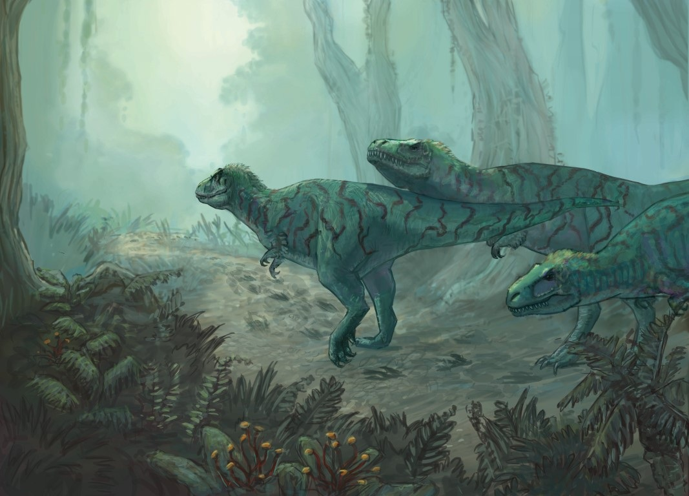

**Figure 3.43**. Painting of predatory dinosaurs hunting for prey in the hot humid forests of the late Mesozoic.

(Cretaceous dinosaurs, Author illustration, created as a work for hire by Temperance Davis. Licensed as CC-BY-SA-3.0.)

### More About Volcanoes

As you know, volcanic activity like that responsible for Earth’s Mesozoic greenhouse climate results from the slow ﬂow of solid rock into and in Earth’s mantle. What’s more, volcanic activity prevents Earth from persisting in an uninhabitably cold state. Even so, volcanic activity is not a response to cooling (or warming) at Earth’s surface. Said diﬀerently, conditions at Earth’s surface produce no short-term eﬀect on Earth’s tectonic engine. Thus, although volcanic activity warms climate, volcanoes do not respond to cool surface conditions. In this way, volcanic activity prevents Earth from remaining in the cold conditions that characterize the runaway icehouse state but not from existing at those conditions for a time ([**Figure 3.38**](https://books.byui.edu/content_images/from_atoms_to_humans/Figure_3_38.jpg)).

Most volcanic activity on Earth occurs at mid-ocean ridges. Thus, the rate of seaﬂoor spreading strongly aﬀects global climate. Ocean ridge volcanism is most active during the breakup of supercontinents and slows as supercontinents coalesce. On the ﬂipside, supercontinent formation builds mountain belts and increases weathering rates. Thus, global climate typically cools as supercontinents form and warms as they break up. This tectonic cycle, which builds and splits supercontinents about every 500 My, has an important broad-scale eﬀect on global climate.

## From Greenhouse to Icehouse in the Mid-Cenozoic

Cenozoic mountain building ended the Mesozoic greenhouse. As the southern part of the supercontinent Pangaea split, Africa and India began moving northward. Then, after ~50 Mya they began to collide with Eurasia. These tectonic movements, illustrated in **Figure 3.44** formed a large east-west belt of mountains that extends from Spain to China and includes the Pyrenees, Alps, and Himalayas.

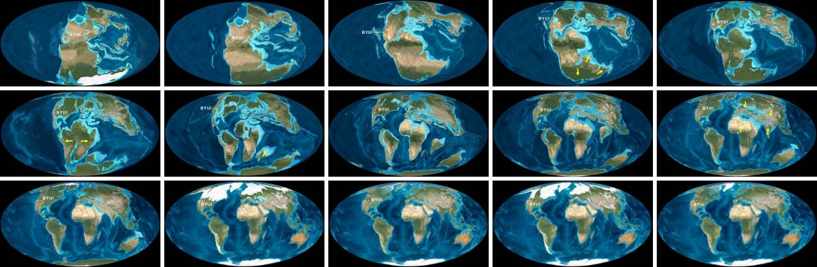

**Figure 3.44**. From upper right: Paleogeographic maps that show the progressive movement of continents from the latest Paleozoic to today. Note how Africa and India emerge from Pangaea, migrate northward, and collide with Eurasia.

(Breakup of Pangea, Author illustration, created as a work for hire by Eden Platt and Jordan Barton, maps after purchasing Ron Blakey images. Licensed as CC-BY-SA-3.0.)

As mountain ranges grew, intensiﬁed weathering and carbon burial cooled global climate. Beginning ~35 Mya, this cooling once again transitioned Earth between climate states, in this case from extreme greenhouse to cold icehouse. By 2.58 Mya, continued cooling had initiated Earth’s modern Ice Age, which we’ll explore in more detail later.

After the end-Mesozoic extinction of ﬂightless dinosaurs, mammals radiated into vacated environmental niches. Earth’s subsequent transition to cooler drier climates caused organisms to further adapt. **Figure 3.45** shows some of the resulting organisms. By ~5 Mya, continued cooling and drying caused forests to recede and Earth’s ﬁrst true grasslands to emerge.

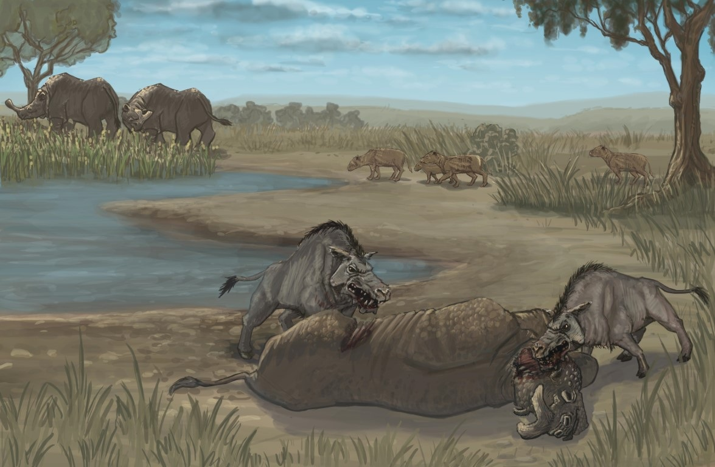

**Figure 3.45**. Painting of a mid-Cenozoic ecosystem in the cool dry interior of North America. The grass-like plants are mostly sedges and bulrushes, not grasses. All the mammals shown are now extinct.

(Oligocene ecosystem, Author illustration, created as a work for hire by Temperance Davis. Licensed as CC-BY-SA-3.0.)

### More About Weathering

Weathering, like that responsible for Earth’s modern icehouse climate, is the physical and chemical disintegration of rock at Earth’s surface. Weathering turns rock into sand, clay, and the dissolved matter is carried by rivers to oceans. In this way, weathering supplies beaches and dune ﬁelds with sand generates the mud that settles from still water, and makes the oceans ‘salty’. Where active, tectonic uplift continually ‘feeds’ ever-deeper rock into the ‘buzzsaw’ of surface weathering. In this way, rocks formed deep in the crust can be seen at Earth’s surface.

The rate of weathering is highest in mountains and during periods of abundant atmospheric CO2. In mountains, exposed rock, high precipitation, and freeze-thaw cycles accelerate weathering. In contrast, abundant CO2 and associated warming accelerate weathering by increasing global rainfall, chemical reaction rates, and the acidity of water. These conditions make rock easier to dissolve. Although weathering both returns CO2 to and removes CO2 from the atmosphere, this important process typically buries far more carbon inside Earth than it releases to the atmosphere.

## Life Drives Climate and Climate Drives Life

As you have seen from our brief introduction to Earth’s climate history, biological changes can tremendously aﬀect Earth’s atmosphere and climate. For example, the emergence of oxygen-generating photosynthesizers in the middle Precambrian produced both the ﬁrst atmospheric free oxygen and an extreme icehouse event. Also, the abundant burial of tree carbon in the late Paleozoic produced both an icehouse climate and the highest-ever concentrations of atmospheric O2.

On the ﬂip side, climatic and other atmospheric changes can drastically alter the nature and development of Earth life. For example, the emergence of abundant free oxygen and transition from icehouse to greenhouse in the late Precambrian set the stage for the emergence of early simple animals. In addition, the drying and cooling of climate that shrank wetland forests in the late Paleozoic generated the selective pressures that produced early seed-bearing plants and the ﬁrst reptiles, which could both survive far from water.

Truly, climate change alters the trajectory of life, and biological change can alter Earth’s climate. Said metaphorically, Earth’s ‘biospheric dragon’ continually ‘brings along’ the very climatic tail that it unceasingly ‘chases’.

Read this online at <https://books.byui.edu/from_atoms_to_humans/321_mother_earth>