# 3.22 How Did We Get Here?

Learning Objectives: • Understand and be able to distinguish between each of the following: icehouse climate state, ice age, glacial period, and interglacial period. Identify the Earth processes that modulate the glacial and interglacial periods of ice ages. Also, identify whether Earth is presently in a glacial or an interglacial period of the modern ice age. • Understand the context for Earth’s present climate. Also, be able to contextualize modern human-induced climate change and describe how it will challenge human civilization.



Dr. Dan Moore and Dr. Brian Tonks, Geology and Physics Departments, BYU-Idaho

We don’t inherit the Earth from our ancestors, we borrow it from our children. —Native American proverb

## Learning Objectives:

* Understand and be able to distinguish between each of the following: icehouse climate state, ice age, glacial period, and interglacial period. Identify the Earth processes that modulate the glacial and interglacial periods of ice Also, identify whether Earth is presently in a glacial or an interglacial period of the modern ice age.
* Understand the context for Earth’s present climate. Also, be able to contextualize modern human-induced climate change and describe how it will challenge human civilization.

By now you know better, but many people (especially Western Christians) think that Earth has ‘pretty much always looked as it does today’. When they envision Earth’s past, they picture an Earth with contemporary continents, mountains, shorelines, and climate. Of course, those seeking to understand Earth as it actually was, is and will be recognize that this ‘static view’ of Earth is a gross distortion of truth.

Even literalist readings of written scripture decry the falsity of this perspective. For example, written scripture clearly indicates that early Earth experienced periods when there were no continents, oceans, plants, or animals. Despite this, some modern people uncritically accept a static Earth. Sadly, these individuals ﬁnd it easy to imagine that they live on a ‘throw away Earth’ that emerged supernaturally a few years ago and will be modiﬁed supernaturally in the near future. Such a worldview makes it diﬃcult to be the careful, conscientious stewards of Earth that written and natural scripture so clearly and powerfully urge.

If you know a good person with such a worldview, don’t despair. There’s actually a really good reason why such an idea could sneak unbidden into human thinking. This myopic view is founded in the following very thin slice of reality: Earth has experienced exceptionally little climate, coastline, or other change in the last 6-7 ky. To be sure, there have been natural devastations aplenty. But large-scale change of the kind we’ve been discussing? Not a stitch!

This means that the entire written record—all of human history—postdates the most recent signiﬁcant Earth changes. Said diﬀerently, human civilization grew up during a brief period when Earth didn’t change much. **Figures 3.46** and **3.47** illustrate this reality. Although false, can you see how the notion that Earth has ‘pretty much always been like it is today’ emerged?

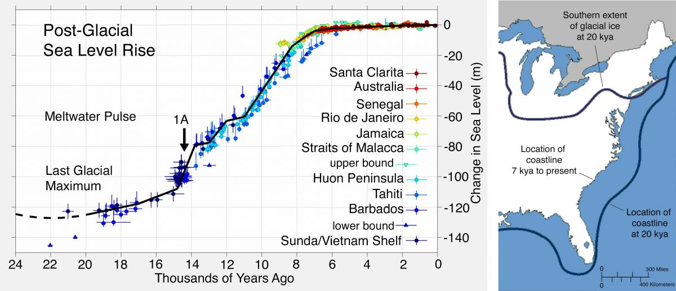**Figure 3.46**. **Left**: Sea level from 24 kya to present. (Wikimedia) **Right**: Eastern US shoreline at 20 kya and from 7 kya to present. Note that sea level and shorelines changed drastically from 20-7 kya, but have remained nearly constant since that time.

(Recent sea level, Author illustration, created as a work for hire by Eden Platt using these images: Sea level rise, Robert A. Rohde, https://bit.ly/37dSjmn, CC-BY-SA-3.0; Recent coastline, USGS, https:// on.doi.gov/3LUIZ5K, public domain, modiﬁed. Licensed as CC-BY-SA-3.0.)

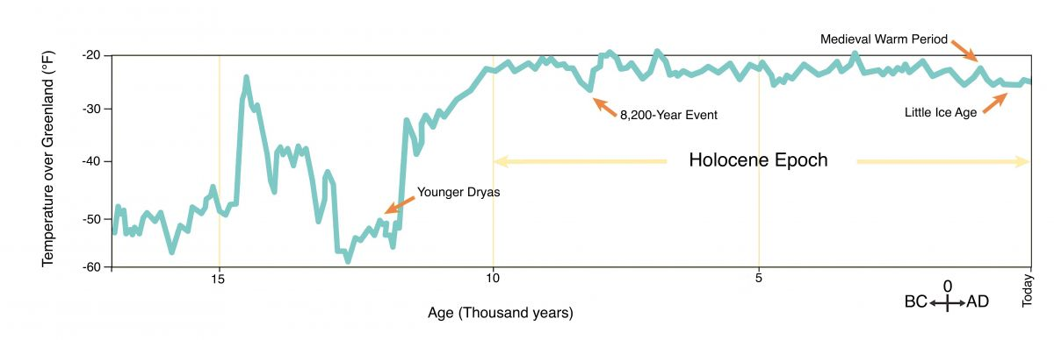**Figure 3.47**. The temperature record from ~19 kya to present. Note that temperature has changed little since 10 kya. (NOAA, recolored)

To illustrate the ‘thinness’ of this worldview, consider that the last ~10 ky represents just one-millionth of one percent of Earth’s history. What’s more, the most recent few thousand years could not be less representative of ‘normal’ Earth conditions. As you know, there is no one set of attributes that are ‘normal’ because changing conditions are the norm for Earth.

## The Recent Development of Modern Climate

Earth’s present climate lies in an interglacial period of the modern ice age ([**Figure 3.40**](https://books.byui.edu/content_images/from_atoms_to_humans/Figure_3_40.jpg)). Recall that icehouse state are periods when Earth is suﬃciently cool to produce substantial polar ice, but ice agesare more severe. During ice ages, there are typically substantial ice caps at both poles. Inside ice ages, cyclical climatic variations produced by variations in Earth’s orbit cause glaciers to expand during glacial periodand retreat during interglacial periods**,** as illustrated in **Figure 3.48**.

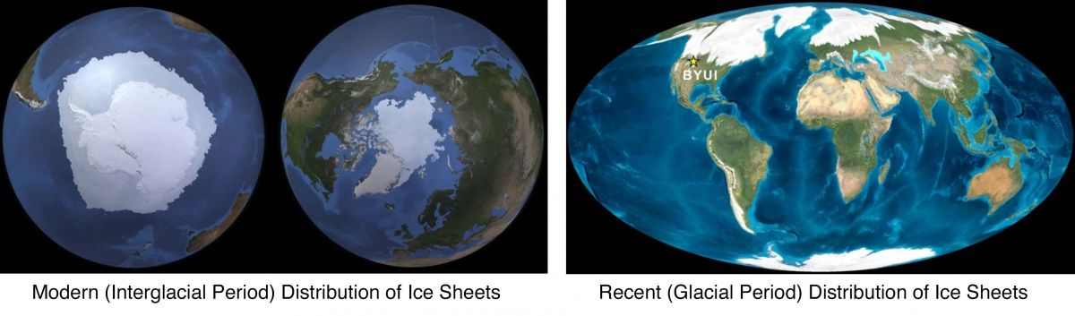**Figure 3.48**. Maximum distribution of ice sheets during the modern interglacial period and during a recent glacial period.

(Polar ice comparisons, Author illustration, created as a work for hire by Eden Platt and Jordan Barton using these images: Aug. 2011, NASA, https://go.nasa.gov/3E8SGLm, public domain; maps after purchased Ron Blakey images. Licensed as CC-BY-SA-3.0.)

To summarize, our modern verdant Earth lies in the Holocene Interglacial Period of the Pleistocene Ice Age, itself a part of the Late Cenozoic Icehouse Climate. **Figure 3.49** shows the transitional cooling that produced modern climate between ~50-35 Mya. As you know, this cooling resulted from enhanced mountain building, weathering, and carbon burial ([**Figure 3.44**](https://books.byui.edu/content_images/from_atoms_to_humans/Figure_3_44.jpg)). As Earth cooled through this transition, the Antarctic ice sheet formed and expanded.

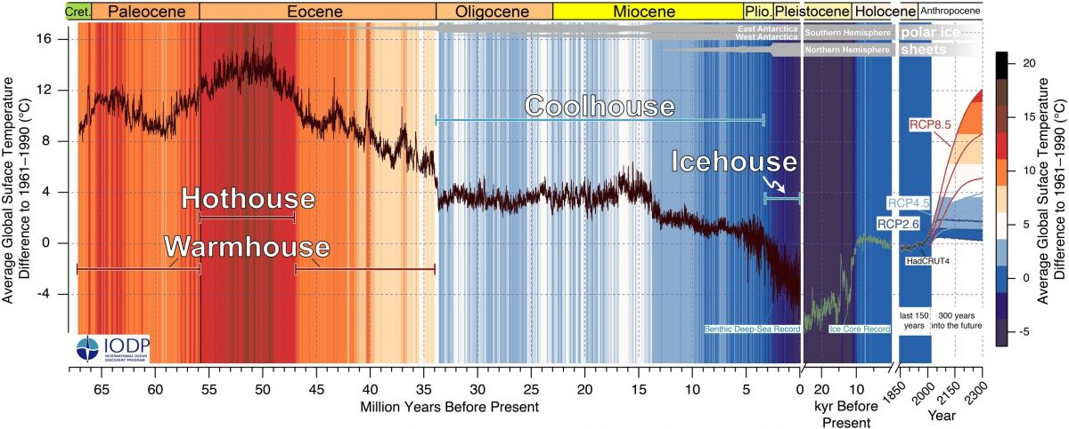

**Figure 3.49**. Cenozoic global temperatures and climate states. Note the broad-scale cooling and the signiﬁcant small-scale variability. Also note the future modeled temperatures shown at right. (NOAA)

By ~2.6 Mya, continued cooling generated a northern ice cap (**Figure 3.48**). The growth of the northern ice cap marked the beginning of the Pleistocene Ice Age. Since that time, ocean sediments indicate there have been ~50 pairs of glacial-interglacial periods. As mentioned, these cyclical periods of cooling and warming result from variations in Earth’s orbit.

The most recent glacial period began ~115 kya, reached its maximum ~23 kya, and then transitioned to the modern (Holocene) interglacial period ~11.7 kya. During the last glacial period ice sheets extended south of the US-Canada border in North America; covered Scandinavia, most of England, and northern Russia in Eurasia; and blanketed Antarctica and much of the Andes in the southern hemisphere (**Figures 3.48**). **Figure 3.46** shows how sea level and shorelines changed as these glaciers retreated.

The transitions between and durations of glacial and interglacial periods are not symmetrical. Instead, temperature falls slowly on the way into relatively long-lived glacial periods, and then it transitions rapidly into short-lived interglacial periods. This forms a sawtooth-shaped temperature pattern, as illustrated in the lower plots of **Figure 3.50**. Another important attribute of the modern ice age involves the duration of glacial-interglacial pairs. These durations changed from ~41 to ~100 ky after ~1 Mya. Signiﬁcantly, these durations match the periods of cyclical variations in Earth’s axis and orbital shape, as illustrated in **Figure 3.50**.

Earth’s tilt varies cyclically between 22.5° and 24.5° every ~41 ky because the Sun, Jupiter, and other planets tug on Earth’s equatorial bulge. Today, Earth’s tilt (23.5°) lies between these extremes and is increasing (**Figure 3.50**). As you know, Earth’s tilt determines the nature of its seasons, but you may not know that a higher tilt produces longer, more extreme seasons. Thus, during periods of high tilt, polar winters are longer and Earth enters summers with more ice. This ice reﬂects more summer sunlight and causes ever-milder summers and ever-cooler winters. This positive response causes ice to advance year to year and can initiate glacial periods.

In addition, gravitational tugs from planets like Jupiter cyclically distort the shape of Earth’s orbit, which completes a cycle about every 100 ky (**Figure 3.50**). During times when Earth’s orbit is mostly circular, Earth receives about the same amount of solar heating throughout the year. In contrast, periods of more-elliptical orbits cause uneven solar heating. During these times, Earth receives more solar heating when near the Sun and less when far from the Sun.

These tilt and orbital shape cycles combine to cause cyclical variations in the time of year (place in Earth’s orbit) when seasons occur. The progressive movement of the seasons through Earth’s orbit (called precession) aﬀects the amount of seasonal sunlight received by Earth. This precession cycle lasts ~23 ky (**Figure 3.50**). In these ways, Earth’s seasons are most extreme when tilt orbital non-circularity is high and winters happen farthest from the Sun. Moreover, extreme seasons favor the advance of glaciers and the initiation of glacial periods.

These orbital cycles were discovered in the 1920s by Serbian geophysicist Milutin Milanković. Collectively, these ‘Milankovitch’ cycles control the annual variations in solar heating that modulate global climate. Even so, sunlight alone is insuﬃcient to explain the amount of cooling and heating associated with transitions between glacial and interglacial periods. This should not surprise us. It simply means that other aspects of Earth’s complex climate system also play important roles. These include the carbon sources and sinks we’ve already discussed plus many other aspects of the climate system—like lags in climate response and the inﬂuence of ocean currents, biological productivity, and long-term cloud cover. Expressed metaphorically, Milankovitch cycles appear to ‘conduct’ Earth’s climate ‘symphony’, but other natural processes produce most of the ‘music’.

This pattern—ampliﬁcation of Milankovitch-cycle heating by other natural processes—appears to produce the transitions between glacial and interglacial periods. Later, we’ll explore how these transitions and other climate changes aﬀected the development of human bodies and behaviors. For example, we’ll discover that the climate warming and stabilization that produced the Holocene allowed humans in the Middle East to build the ﬁrst temples, domesticate the ﬁrst plants and animals, and construct the ﬁrst cities.

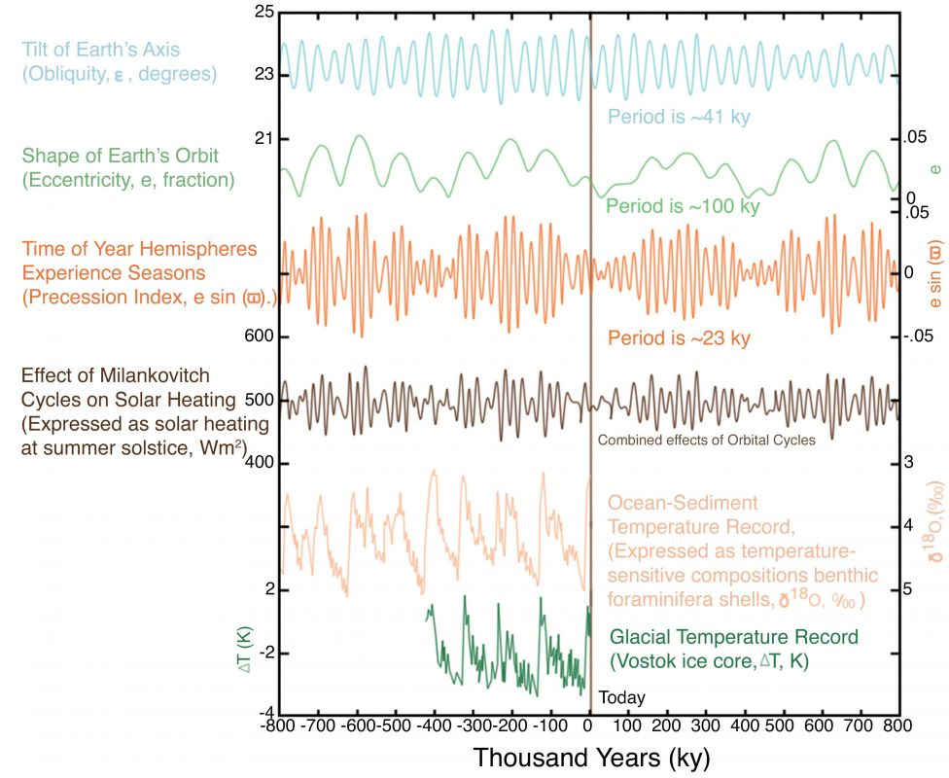

**Figure 3.50**. **Upper Four Plots**: Orbital cycles that modulate global temperature and glacial-interglacial cycles by aﬀecting seasonal variations in solar heating. **Lower Two Plots**: Sawtooth-shaped temperature variations of the most recent glacial-interglacial cycles as recorded in ocean sediments and glacial ice cores.

(Milankovitch cycles, Author illustration, recolored and labeled as a work for hire by Eden Platt from Incredio image, includes data from NASA/J.R. Petit/L.E. Lis iecki, https://bit.ly/3vfhkFZ, CC-BY-SA-4.0. Licensed as CC-BY-SA-3.0.)

## Climate In the Near Future

Modern climate change is a contentious topic in some sectors of present society, and separating fact from ﬁction can be challenging for those who know little about Earth, climate systems, or how science develops explanations in which humanity can exercise conﬁdence. Questions such as the following burn bright in the minds of many: I hear so much about climate change, what is true and what is hyperbole? Should humanity be concerned? What should society do about our present situation? What should I do about it? Although the answers to some of these questions lie far outside our scope, the aspects of climate we’ve addressed can contextualize answers to these questions. We begin with simple, foundational truths that will allow us to explore anthropogenic climate change.

Nearly everything you do and use requires energy, and most of that energy comes from burning fossil fuels like petroleum and coal. Burning these fuels moves carbon from solid Earth to the atmosphere much faster than natural systems can remove it. As a result, climate warms as atmospheric CO2 levels rise.

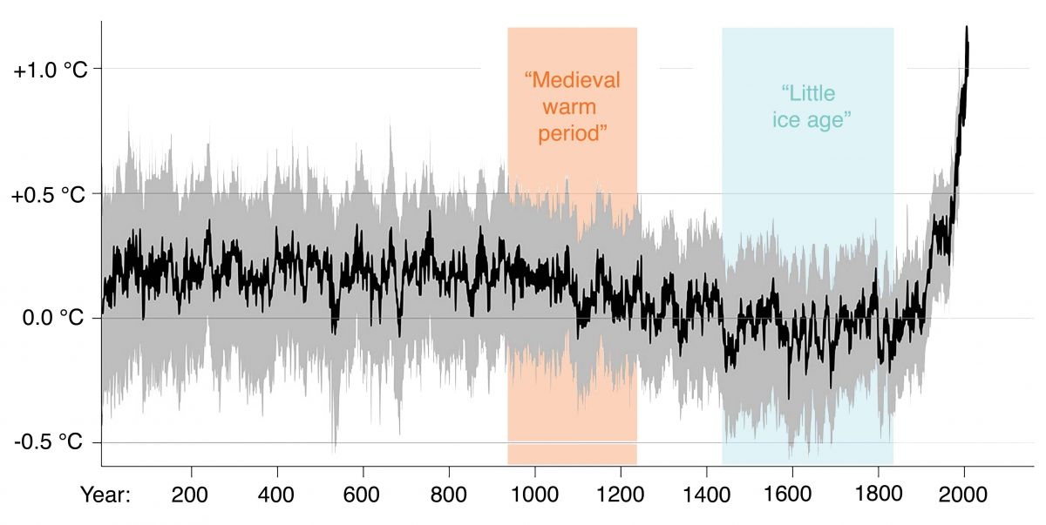

**Figure 3.51.** Global average temperature since 2 kya.

(Recent temperature, RCraig09 based on plot by Ed Hawkins, https://bit.ly/3ve UyOm, CC-BY-SA-4.0.)

Humans began burning abundant fossil fuels at the start of the Industrial Revolution, in the late 1700s. Natural records demonstrate that the concentration of atmospheric CO2 from 10 kya to the Industrial Revolution was ~250 molecules per million (ppm). Today, CO2 concentrations are well over 400 molecules per million, and they are rising. **Figure 3.51** shows global temperatures since the birth of Christ, and **Figure 3.52** shows that natural processes cannot themselves account for the observed warming of ~2°F (>1°C) . These and other observations strongly suggest that human burning of fossil fuels has increased atmospheric CO2 and warmed global temperatures.

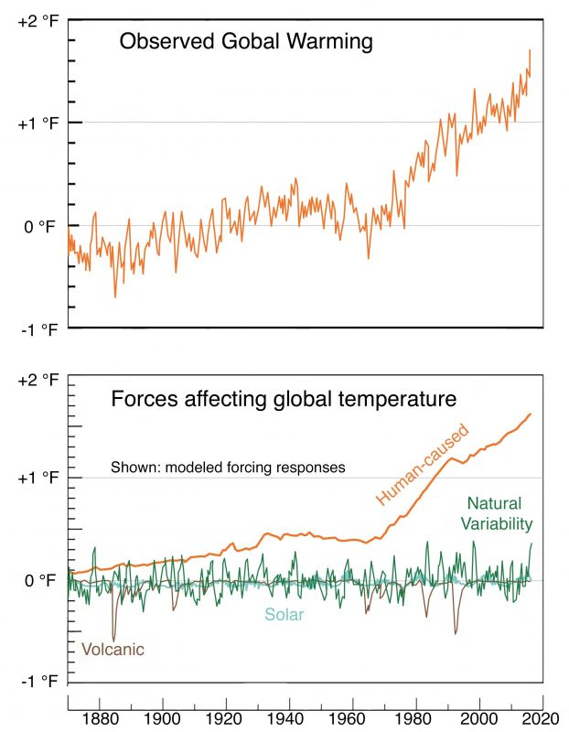

**Figure 3.52**. Global observed surface temperatures since 1880 (top), and modeled climate contributions of natural and human processes (bottom).

(Historical temperature, reworked version of RCraig09 image—itself based on USGRCP and Canty and others plots, Observed warming, https://bit.ly/3JBmhxX, CC-BY-SA-4.0.)

Having explored basic, well-established principles and observations, we’re ready to explore issues about which there is much disagreement and confusion among nonspecialists. For example, as global temperatures rise, will Earth and Life be okay? Yes, Earth will be ﬁne, but the answer for life is more complicated. Although life can thrive in warmer temperatures, the ability of organisms to adapt is strongly dependent on the rate of climate change. It’s often how quickly climate changes, not the change itself, that causes extinction. Present rates of climate change are similar to those Earth experienced near the end of the Paleozoic when rapid carbon release from volcanoes and coal produced Earth’s largest animal extinction. In short, signiﬁcant fractions of current biodiversity are in danger of going extinct. It’s diﬃcult to overstate this conclusion.

Well, how about humanity: Will we be okay? As for life, the answer depends on what you mean by ‘okay’. Without question, humanity has the ability to greatly reduce our impact and to adapt—but both require desire, planning, eﬀort, sacriﬁce, and money…lots of money. Whether we choose to proactively reduce emissions or are forced to respond to the eﬀects of rising temperatures, it’s going to be really expensive.

To get a sense of how present and future climate change will aﬀect humanity, let’s look to the past—to well-documented events in human history. Few historians disagree that climate change played signiﬁcant—even dominant—roles in the destabilization and eventual demise of many ancient peoples, including these:

* The Akkadian Empire in the Middle East and the Old Kingdom in Egypt collapsed when the climate dried ~4.2 kya.
* The Maya civilization in Mesoamerica collapsed when the climate dried in the 800s AD.
* The Vikings left Greenland, peoples of the American Southwest left their cities, and the Khmer civilization in southeast Asia collapsed during a period of cooling and drying known as ‘the Little Ice Age’ (from 1300-1800s; **Figure 3.51**).

Harvard Archaeologist Dr. Jason Ur has said “When we excavate the remains of past civilizations, we very rarely ﬁnd any evidence that they as a whole society made any attempts to change in the face of a drying climate, a warming atmosphere or other changes [….] I view this inﬂexibility as the real reason for collapse” (Source NASA). Additional examples of groups aﬀected by climate change abound, including changes that destabilized societies without causing their demise.

Before proceeding, take a moment to correlate the timing of the events listed above with the temperature record in **Figure 3.47**. Notice that the examples provided above are all associated with very small climate change events. Also note that even modest projections of future temperature (**Figure 3.49**) represent relatively large changes, and extreme projections involve rapid transition to a greenhouse climate. Taking into account sound principles, observed reality, historical eﬀects and the like, it’s diﬃcult to make a valid case that human-induced climate change won’t signiﬁcantly aﬀect present human civilizations.

The reality is that any signiﬁcant degree of climate change is bad for human civilization, no matter its cause. Thus far, humanity has treated Earth as if it never changes and will always freely provide the same amount of what we need. The moment we must pay for things we take for granted—like steady sea level or climate—life becomes very expensive, very rapidly. That expense will negatively impact the standard of living, and people get really grumpy, really quickly when their standard of living drops.

Climate change is expensive because it requires societies to adjust. For example, warming climate raises sea levels and alters regional climates. So humanity will need to make stupendously expensive changes like moving coastal cities. Unfortunately, most (all?) governments are unprepared to ﬁnance or carry out these kinds of activities, and history is replete with examples of societies being destabilized by much smaller issues. Sadly, such destabilization typically produces human conﬂict and abundant death.

So, what should humanity do about all this? First, recall that deciding what humanity does requires individuals and societies to make value judgments based on the best available scientiﬁc data. Said diﬀerently, any wise course of action must be consistent with scientiﬁc ﬁndings, but those ﬁndings alone cannot uniquely identify a course of action. Prudent paths forward likely involve signiﬁcantly reducing fossil fuel emissions and preparing for climate warming while trying to minimize impacts on the standard of living.

Reducing fossil fuel emissions requires increasing our reliance on other sources of energy. At present, nuclear power is the only source of energy that can replace carbon-based sources without decreasing the standard of living. Of course, nuclear energy can (and should) be supplemented by renewable sources like solar, wind, and wave energy, but these sources alone are insuﬃcient to replace carbon-based sources.

The degree to which humanity decides to approach climate change with wisdom will depend at least in part on you because global solutions to climate change will consist of international, national, regional, community, and individual solutions. As you make choices and vote on topics related to climate, recognize that these issues have become extremely politicized and that there are many that would seek to deceive you. We strongly encourage you to develop an informed perspective using reputable sources of climate science and to be a wise steward of our habitable home. How you and your generation choose to handle human-induced climate change will impact the future.

## A Final Word

As we complete our exploration of the formation, functioning, and history of Earth, we invite you to take a moment to assess what you have learned about our Goldilocks planet. Do you now see layers of rock as pages of natural scripture that tell the story of the Ongoing Creation of Earth to anyone with ‘ears to hear’? Have you come to know the Creator better? Do you think about Earth’s habitability in the same way? Has apparent conﬂict between scientiﬁc and religious accounts of Creation diminished? Have your ideas about and commitment to human stewardship changed or been strengthened?

We witness that natural processes and lawful interactions produced Earth and made it habitable. In other words, we assert that Earth formed and developed into our self-maintaining habitable home through lawful self-assembly. What’s more, we aﬃrm that a self-assembled Earth is fully consistent with the assertion that God formed Earth.

We hope you’ve enjoyed this important Earthly portion of our journey From Atoms to Humans. Having looked at the lawful origins of order in Earth, we now turn our focus to order in Life and the order in us.

## For The Curious

The Goldilocks Planet: The Four Billion Year Story of Earth's Climate by Zalasiewicz and Williams (2013, Oxford University Press).

Climate: A Very Short Introduction by Mark Maslin (2013, Oxford University Press).

The Ice Age: A Very Short Introduction by Jamie Woodward (2014, Oxford University Press).

Read this online at <https://books.byui.edu/from_atoms_to_humans/322_how_did_we_get_h>